RUNNING HEAD: SYNCHRONY AND OBEDIENCE

Synchrony and Destructive Obedience

December 14th, 2011

Word Count: 3,277
Abstract
An experiment demonstrated that cultural practices involving synchrony can make people more likely to engage in destructive obedience at the behest of authority figures. Participants instructed to follow a leader while walking in-step with him felt closer to him and were more willing to kill sow bugs at the leader’s request in an ostensibly different experiment than were participants in other conditions. The findings are the first to indicate that synchronous activities may be used to influence leader – follower relations.

Keywords: Persuasion, Social Influence, Synchrony, Obedience, Morality, Ethics

Synchrony and Destructive Obedience
Few images are as chilling as those of Nazis goose-stepping and saluting en masse at the Hitler-led rallies at Nuremburg. The images recall tragic obedience to authority and serve as a physical metaphor for the Gleichschaltung, or Nazi efforts to synchronize all aspects of 1930’s German society. Hitler was not alone in incorporating synchrony in his political gatherings. Mussolini also incorporated synchronous activity in his fascist rallies, and political gatherings throughout the world still include synchronous chanting and synchronous movement.
Could the synchrony in these rallies have promoted destructive obedience? Prior research has demonstrated that the way people experience their social world is closely linked to the physical and somatic stimuli surrounding them (e.g., Barsalou, 1999; Varela, Thompson, & Rosch, 1991; Zhong & Leonardelli, 2008). Consistent with this work on embodied emotion, researchers have shown that when people move in synchrony with others they begin to feel more socially connected and compassionate (Valdesolo & DeSteno, 2011). Indeed, prior research has established that engaging in physical synchrony with others increases feelings of group cohesion (Camilleri, 2002), social connectedness (Hove & Risen, 2009; Macrae, Duffy, Miles, & Lawrence, 2008; Marsh, Richardson, & Schmidt, 2009; Miles, Nind, Henderson, & Macrae, 2009; Schmidt & Richardson, 2008), and cooperation within groups (Valdesolo, Ouyang, & DeSteno, 2010; Wiltermuth & Heath, 2009). Research has also established that people are more likely to comply with requests from those to whom they feel socially connected (Burger, Soroka, Gonzago, Murphy, & Sommervell, 2001; Dolinski, Nawrat, & Rudak, 2001; Emswiller, Deaux, & Willits, 1971; Williamson & Clark, 1992). As such, incorporating synchrony into these rallies may have increased people’s willingness to follow the directives issued by their leaders.
The recent discovery that synchrony can lead people to conform to interaction partners’ estimates in estimation tasks (Paladino, Mazzurega, Pavani, & Schubert, 2010) supports the idea that synchronous action may promote obedience. So too does the recent finding that synchrony can promote compliance with a peer’s request to aggress against outgroup members by issuing a noise blast in competitive tasks (Wiltermuth, 2012).
However, there are numerous reasons to doubt that synchrony would increase obedience to commit destructive acts. Although compliance and obedience both involve social influence, the two phenomena are distinct. Obedience occurs when people follow orders or directives, whereas compliance occurs when someone acquiesces to fulfill another person’s request (Cialdini & Goldstein, 2004). Because directives are generally more direct than requests, they often come across as less polite. Whereas the affiliation effected by synchrony may boost compliance with requests, it may be less effective at boosting obedience because the directness of the order may attenuate the boost in affiliation. Additionally, while people tend to follow most readily the requests and instructions of authority figures who use both harsh and soft tactics (Emans, Munduate, Klaver, & van de Vliert, 2003), it is unclear whether synchrony could influence obedience when an authority figure is already capitalizing on status differences and directly telling others what to do. Further, the social connection that synchrony instills amongst peers may not be instilled when status differences exist between people – as is the case in the studies that follow.
Moreover, most work on behavioral synchrony suggests that it creates positive, pro-social emotions such as collective effervescence, communitas, and collective joy (Ehrenreich, 2006; McNeill, 1995). Synchrony therefore seems more likely to foster sociality and pro-social behavior than antisocial or destructive behavior (but see Wiltermuth, 2012). If synchrony causes these pro-social emotions, it may reduce the likelihood that people would obey directives to commit destructive behaviors. Indeed, when military leaders employ synchrony rituals to spur their followers to obey their directives, people often question whether the engagement in the synchronous activity actually leads to followers to obey. To wit, scholars have described fascist rallies as spectacles designed to awe onlookers rather than to connect the participants (Brecht, 1967; Klemperer, 1946 / 1966; Strzelczyk, 2004).
Research on the related topic of mimicry, which differs from synchrony in that it involves a time lag and must generally be nonconscious to produce its effects, also suggests that incorporating synchrony into group rituals may be ineffective as a tool for leaders wanting to motivate their followers to commit destructive acts. This work has repeatedly found that common movement with others leads to a general pro-social orientation, such that people not only to behave more pro-socially toward those mimicking them but also toward people in general (Stel, Van Baaren, & Vonk, 2008; van Baaren, Holland, Kawakami, & van Knippenberg, 2004). For example, van Baaren, Holland, Steenart, and van Knippenberg, (2003) found that people who had been mimicked by a confederate were more willing than those who were not mimicked to help another person or donate money to a charity.
Given that both synchrony and nonconscious mimicry seem to create general pro-social orientations and little work has explored the dynamics of mimicry or synchrony across leader-follower relations, we do not yet know if either synchrony or nonconscious mimicry can spur people to act destructively at the request of an authority figure. The following studies examine whether synchronous activity could make people more obedient to authority figures (i.e. the experimenter¹). They also seek to clarify our understanding of the mechanism through which synchrony effects obedience by using a manipulation of synchrony unlikely to improve participants’ moods. Following on work by Marsh, Richardson, Baron, and Schmidt (2006), it also tests the hypothesis that in-phase coordination (i.e. synchrony) generates greater connection/attraction than does anti-phase coordination. To obtain clean measures of participants’ feelings of emotional connection with the experimenter, I conducted two studies. The first study tests whether the manipulation fosters feelings of social connection; the second study tests whether the manipulation increases obedience to the instructions².

Study 1: Connection

Method
Seventy students (51% female, Age: M = 21.3 SD = 3.0) at a private university on the West Coast of the United States began the study by drawing one of three slips of paper from an envelope. Arriving individually, participants were told to follow the instructions provided on the slip they selected but not to reveal these instructions to the experimenter. These slips of paper instructed participants to follow the experimenter on a walk around campus in one of three ways. The participant walked alone behind the experimenter in all conditions. The cover story was that the study examined links between memory and movement.
Synchrony Manipulation
Participants were randomly assigned to one of three conditions: synchrony, coordinated but asynchronous (i.e. out-of-step), and control. Participants in the synchrony condition received instructions to walk in-step with the experimenter, left foot with left foot and right with right. Participants in the coordinated but asynchronous condition received instructions to take a step with their right foot when the experimenter stepped with his left foot and to take a step with their left foot when the experimenter stepped with his right foot. This condition could be considered anti-phase coordination (Marsh et al., 2009; Miles et al., 2010). Control condition participants received instructions to walk with the experimenter. In all conditions the experimenter wore headphones and asked participants to walk a few steps behind him to enable him to remain blind to condition.
Dependent Variables
Participants completed a questionnaire consisting of a series of questions asking them to indicate on a seven-point continuous scale (1: not at all, 7: very much) how connected they felt to the experimenter, how close they felt to the experimenter, how much they liked the experimenter, and how similar they felt to the experimenter. They also completed the Inclusion of Other in the Self Scale (IOS; Aron, Aron, & Smollan, 1992). They next indicated the degree to which they walked in-step with the experimenter. Additionally, they indicated how sad, angry, irritated, happy, joyful, and elated they felt. Finally, they indicated how difficult, demanding, and requiring of effort it was to walk behind the experimenter as they were instructed.
Results
Treatment of Data
I conducted a principal component analysis of fifteen items using a varimax rotation to examine the structure of participants’ responses. Three factors explained 62.2% of the variance. A fourth factor did emerge, but it held no primary loadings. Based on the results of this principal component analysis, I combined ratings of task difficulty, effort required to complete the task, and how demanding the task was into a single measure of task difficulty, α = .91. Although both positive and negative emotions loaded highly onto the second and third components, the reliability of a combined index of emotions was unacceptably low, α = .53. I therefore combined the measures of happiness, joyfulness, and elation into a single measure of positive affect (α = .85) and the measures of anger, irritation, and sadness into a single measure of negative affect, α = .77. Finally, I combined ratings of closeness, connectedness, liking, similarity, and self-other overlap with the experimenter into a single measure of emotional connection, α = .84.
Manipulation Check
Participants in the synchronous condition indicated that they made more of an effort to walk in-step with the experimenter than did those in the coordinated but asynchronous condition (t(67) = 2.53, p = .01) or control condition, t(67) = 4.36, p < .001.
Main Analyses
Table 1 displays mean levels on key variables by condition. A one-way between subjects ANOVA (conditions: synchrony vs. coordinated but asynchronous vs. control) revealed significant differences between how emotionally connected participants felt with the experimenter, F(2,67)=3.76 p = .03. Consistent with predictions, participants in the synchrony condition felt more emotionally connected to the experimenter than did those in the control condition (t(34.7)=2.37, p = .02, d = .68) and, on a marginally significant basis, those in the coordinated but asynchronous condition (t(34.0)=1.83, p = .08, d = .53)³. An examination of the variables comprising the emotional connection index revealed the strongest effects for self-other overlap and feelings of connectedness. Participants in the synchrony condition felt greater feelings of connectedness with the experimenter (M = 3.48, SD= 1.49) than did those in the control condition (M = 2.67, SD= 0.77; t(34.8)=2.37, p = .02, d = .68) and those in the coordinated but asynchronous condition, (M = 2.86, SD= 0.74), t(34.0)=1.83, p = .08, d = .53. Using post hoc Fisher LSD multiple comparisons also resulted in a significant difference between the synchronous and control conditions and a marginally significant difference between the synchronous and coordinated but asynchronous condition.
Participants in the synchrony condition did not report experiencing more positive emotion or less negative emotion than did those in the control or coordinated but asynchronous condition, ps > .15. Participants rated the walking task as less difficult in the control condition than they did in the synchronous (t(67)=3.99, p = .001) and the coordinated but asynchronous condition, t(67)=4.69, p = .001. The synchronous and the coordinated but asynchronous conditions did not differ on task difficulty, p > .4.
<INSERT TABLE 1>
Study 2: Destructive Obedience

Method
Eighty-nine participants (65% female, Age: M = 19.5 SD = 3.2) were told that they would be participating in two experiments during the session. In the first experiment they individually followed an experimenter on a walk around campus in a task that ostensibly looked at memory and movement. After this experiment, participants were given a memory task for sights that they passed around campus. They were asked such questions as: “How many restrooms did you pass in your walk?” and “How many stairs did you climb on your walk?” Participants were then told that the experiment had been designed to test links between movement and memory. In an ostensibly different experiment, they were directed to put sow bugs into a funnel that led into a coffee grinder in order to kill the sow bugs. The number of bugs participants inserted into the funnel served as the measure of obedience.
Synchrony Manipulation
Participants were randomly assigned to one of the three conditions detailed in Study 1 (synchrony with the same experimenter, coordinated but asynchronous (i.e., out-of-step), and control) or a fourth condition in which they walked in synchrony with a different experimenter than the one who would conduct the second experiment. Only when the participant walked behind a different experimenter was the primary experimenter aware of the participant’s condition.
The Bug-Grinding Task
The experimenter read from a script instructing participants that they would be completing an ostensibly different experiment that the experimenter was conducting to understand people’s physiological responses to performing “tasks that people in some parts of the world may find objectionable.” Participants then viewed twenty sow bugs (Porcellio scaber), which were preset in plastic cups placed beside an extermination machine (i.e. modified coffee grinder), a device used by Martens, Kosloff, Greenberg, Landau, and Schmader (2007) and shown in Figure 1. The experimenter instructed participants to “put as many of these bugs as you can in the funnel within thirty seconds.” Because the instructions were to put as many bugs as they could in the funnel within thirty seconds, those participants who did not make efforts to put bugs into the machine continuously were not obeying the experimenter. Thus, the number of bugs inserted into the grinder served as the measure of obedience. The experimenter also told them that the bugs would fall from the funnel through a tube to the grinding blades of the “extermination machine”, which would be run for three seconds at the end. Unbeknownst to participants, a stopper prevented any the bugs from reaching the grinding blades. While they were performing the task, participants held in their non-dominant hand a hand dynamometer, which they were told measured their physiological reactions. Participants did not know that the hand dynamometer was a dynamometer, and therefore did not know which physiological reactions were being measured. After thirty seconds, the grinder was run for three seconds. The experimenter then probed participants for suspicion and asked them to indicate on a continuous seven-point “How much do you think crushing bugs is immoral? (1: Not at all, 7: Very much)”. He then debriefed them.
<INSERT FIGURE 1>
I expected that participants in the synchrony with the same experimenter condition would put more bugs into the extermination machine than would participants in any other condition. When participants were not in-step with the experimenter or when they were in-step with a different experimenter, I expected that they would not put as many bugs into the extermination machine.
Results
Treatment of Data and Manipulation Checks
Table 2 illustrates the extent to which participants in each condition walked-in step with the experimenter and the number of bugs they put into the funnel. As a manipulation check, we asked participants how much of an effort they made to walk-in step with the experimenter. Participants in the synchrony with the same experimenter condition indicated that they made more of an effort to walk in-step with the experimenter than did those in the coordinated but asynchronous (t(83) = 2.15, p = .03) or control conditions, t(83) = 5.04, p < .001. Participants in the synchrony with the other experimenter condition also made more of an effort to walk in-step with the experimenter than did those in the coordinated but asynchronous (t(83) = 5.04, p = .001) or control conditions, t(83) = 3.52, p = .001. Across conditions, participants indicated that they viewed crushing bugs as moderately immoral (M = 3.84, SD = 1.85). Condition had no effect on how immoral participants viewed crushing bugs to be, F(3,84) = 1.05, p = .38.
Main Analyses
A one-way ANOVA (conditions: synchrony with the same experimenter vs. synchrony with the other experimenter vs. coordinated but asynchronous vs. control) revealed that condition significantly affected the number of bugs participants put into the funnel, F(3,85)=6.05 p = .001. Participants in the synchrony with the same experimenter condition were more willing to obey the instructions to put as many bugs as possible into the funnel leading into the coffee grinder. Participants in the synchrony with the same experimenter condition put approximately 54% (i.e., 2.75) more bugs into the funnel than did those in the control condition, t(85)=2.97, p = .004, d = .73. They also put approximately 38% (i.e., 2.09) more bugs into the funnel than did participants in the coordinated but asynchronous condition (t(85)=2.20, p = .03, d = .64) and twice as many bugs (i.e., 3.69) into the funnel than did participants in the synchrony with the other experimenter condition, t(85)=4.16, p = .001, d = 1.20. All reported contrasts were also significant when I conducted post hoc Fisher LSD multiple comparisons.
<INSERT TABLE 2>
General Discussion
People who acted in physical synchrony with an authority figure (i.e., the experimenter) were more likely than people in other conditions to engage in destructive obedience. Study 1 participants felt closer to the experimenter when they behaved synchronously. Study 2 participants were more likely to obey the experimenter’s instructions to put as many sow bugs as possible into an “extermination machine” after following him while walking in-step with him than they were after following him while either walking normally or walking in a coordinated albeit asynchronous manner with him. Suggesting that the cohesion created by synchrony drove the differences between conditions, participants also put more sow bugs into the machine after walking in synchrony with him than they were after walking in-step with a different experimenter. Thus, synchrony led people to be more likely to engage in destructive obedience, a phenomenon studied most famously by Stanley Milgram (1963; 1974) in his experiments revealing that participants were surprisingly willing to follow the experimenter’s directive to administer electrical shocks to other participants.
While the rallies of Nuremburg may seem far removed from our own time, synchronous actions and chants still appear in political and religious rallies throughout the world. As such, the knowledge that synchronous rituals may foment destructive obedience may prove useful in understanding behavior in such contexts. The current study also enhances our understanding of how leaders may influence followers in dyadic interactions. In particular, it shows that asking followers to perform actions at the same time as leaders may not exhaust the followers’ willingness to obey, but instead may make them more likely to obey subsequent directives.
The present work is not without limitations. First, the unethical behavior studied was relatively innocuous. Killing bugs simply is not as unethical as killing people. While the reasons for choosing this relatively innocuous behavior over killing humans is patently obvious, caution should be exercised when using the current findings to understand if/how synchrony can be used to instigate more extreme examples of unethical behavior. Second, the current experiment used active forms of synchrony in which people moved their bodies in-time with others. Recent work by Paladino et al. (2010) has shown that more passive forms of synchrony can also increase social cohesion. The present work does not address whether such forms of synchrony increase obedience.
In conclusion, the present research indicates that cultural practices involving synchrony (e.g., marching, dance, and chanting) may enable leaders to bind their followers to them and, thereby, make those followers more likely to obey their directives. Synchrony can therefore be used as a tool to spur people to act destructively at the behest of their leaders.
References
Aron, A., Aron, E. N., & Smollan, D. (1992). Inclusion of other in the self scale and the structure of interpersonal closeness. Journal of Personality and Social Psychology, 63, 596–612.
Ashton-James, C., Van Baaren, R. V., Chartrand, I. L., Decety, J. & Karremans, J. (2007). Mimicry and me: The impact of mimicry on self-construal. Social Cognition, 25, 518-535
Barsalou, L.W. (1999). Perceptual symbol systems. Behavioral and Brain Sciences, 22, 577–609.
Brecht, B. (1967). Der Messingkauf: 1937 – 1951. Gesammemelte Werke 16: Schriften zur Theater 2. Frankfurt am Main: Suhrkamp.
Burger, J.M., Soroka, S., Gonzago, K., Murphy, E., & Somervell, E. (2001). The effect of fleeting attraction on compliance to requests. Personality and Social Psychology Bulletin, 27, 1578-1586.
Camilleri, V. (2002). Community building through drumming. The arts in psychotherapy, 29 (5), 261-264.
Cialdini, R. B. & Goldstein, N. J. (2004). Social influence: Compliance and conformity. Annual Review of Psychology, 55, 591 – 621.
Diener, E. (1977). Deindividuation: Causes and consequences. Social Behavior and Personality, 5 (1) 143-156.
Dolinski, D., Nawrat, N., & Rudak, I. (2001). Dialogue involvement as a social influence technique. Personality and Social Psychology Bulletin, 27, 1395-1406.
Ehrenreich, Barbara. (2006). Dancing in the streets. New York: Metropolitan.
Emans, B. J. M., Munduate, L., Klaver, E., & van de Vliert, E. (2003). Constructive consequences of leaders’ forcing influence styles. Applied Psychology: International Review, 52, 36 – 54.
Emswiller, T., Deaux, K., & Willits, J. E. (1971). Similarity, sex, and requests for small favors. Journal of Applied Social Psychology, 1, 284-291.
Haidt, J., Seder, J.P, & Kesebir, S. (2008). Hive psychology, happiness, and public policy. Journal of Legal Studies, 37.
Hove, M. J., & Risen, J. L. (2009). It’s all in the timing: Interpersonal synchrony increases afﬁliation. Social Cognition, 27, 949–960.
Klemperer, V. (1946 / 1966). Die unbewältigte Sprache. Darmstadt: Melzer.
Macrae, C. N., Duffy, O. K., Miles, L. K., & Lawrence, J. (2008). A case of hand waving: Action synchrony and person perception. Cognition, 109, 152–156.
Marsh, K. L., Richardson, M. I., Baron, R. M., & Schmidt, R. C. (2006). Contrasting approaches to perceiving and acting with others. Ecological Psychology, 18, 1–38.
Marsh, K. L., Richardson, M. J., & Schmidt, R. C. (2009). Social connection through joint action and interpersonal coordination. Topics in Cognitive Science, 1, 320–339.
Martens, A., Kosloff, S., Greenberg. J., Landau, M.J., & Schmader, T. (2007). Killing begets killing: Evidence from a bug-killing paradigm that initial killing fuels subsequent killing. Personality and Social Psychology Bulletin, 33, 1251– 264.
McNeill, W.H. (1995). Keeping together in time: Dance and drill in human history. Harvard University Press: Cambridge, Massachusetts.
Miles, L. K., Nind, L. K., Henderson, Z., & Macrae, C. (2010). Moving memories: Behavioral synchrony and memory for self and others. Journal of Experimental Social Psychology, 46(2), 457-460.
Milgram, S. (1963). Behavioral study of obedience. Journal of Abnormal and Social Psychology, 67: 371–378.
Milgram, S. (1974) Obedience to authority: An experimental view. New York: Harper & Row.
Paladino, M., Mazzurega, M., Pavani, F., & Schubert, T. W. (2010). Synchronous multisensory stimulation blurs self-other boundaries. Psychological Science.
Schmidt, R. C., & Richardson, M. J. (2008). Dynamics of interpersonal coordination. In A. Fuchs & V. K. Jirsa (Eds.), Coordination: Neural, behavioral and social dynamics (pp. 281–307). Berlin: Springer-Verlag
Stel, M., Van Baaren, R. B., Vonk, R. (2008). Effects of mimicking: Acting prosocially by being emotionally moved. European Journal of Social Psychology, 38 (6), 965-976.
Stern, J.P. (1975). The führer and the people. Berkeley, California, p. 85-90.
Varela, F.J., Thompson, E., & Rosch, E. (1991). The embodied mind: Cognitive science and human experience. Cambridge, MA: MIT Press.
Valdesolo, P. & DeSteno, D.A. (2011). Synchrony and the social tuning of compassion. Emotion, 11(2), 262-266.
Valdesolo, P., Ouyang, J., & DeSteno, D. The rhythm of joint action: Synchrony promotes cooperative ability. Journal of Experimental Social Psychology, 46, 693 – 695.
van Baaren, R. B., Holland, R. W., Kawakami, K., & van Knippenberg, A. (2004). Mimicry and prosocial behavior. Psychological Science, 15, 71–74.
Williamson, G. M., & Clark, M. S. (1992). Impact of desired relationship type on affective reactions to choosing and being required to help. Personality and Social Psychology Bulletin, 18, 10-18.
Wiltermuth, S. S. (2012). Synchronous activity boosts compliance with requests to aggress. Journal of Experimental Social Psychology, 48 (1), 453 - 456.
Wiltermuth, S. S., & Heath, C. (2009). Synchrony and cooperation. Psychological Science, 20, 1-5.
Zhong, C. & Leonadelli, G. J. (2008). Cold and lonely: Does social exclusion literally feel cold? Psychological Science, 19 (9), 838 – 842.

Notes
Please see Diener (1977, pg. 148) for a discussion of the experimenter as an authority figure.
2 Asking participants to indicate the strength of their feelings of emotional connection prior to instructing them to kill sow bugs may have affected participants’ willingness to engage in these actions, as it would have highlighted that the experiment tested the strength of their feelings of emotional connection. It also would have been problematic to ask participants about their feelings of connection with the experimenter after they had been instructed kill pill bugs.
3 Levene’s test of homogeneity of variance was significant (F(2,67) = 8.19, p = .01). I therefore used the corrected t-test in this analysis and all subsequent analyses involving measures of emotional connection.

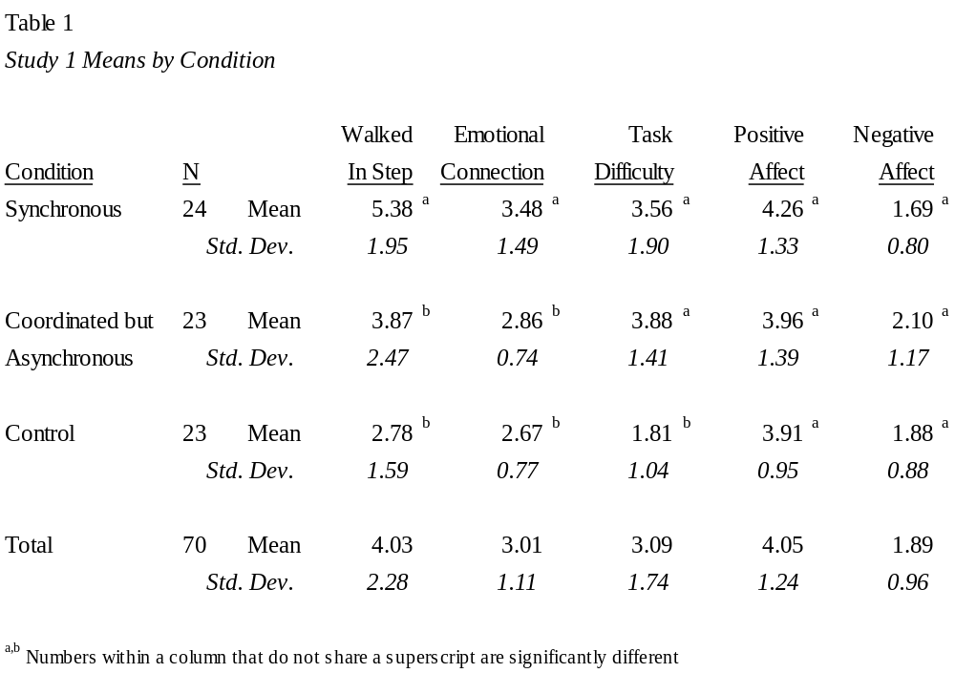

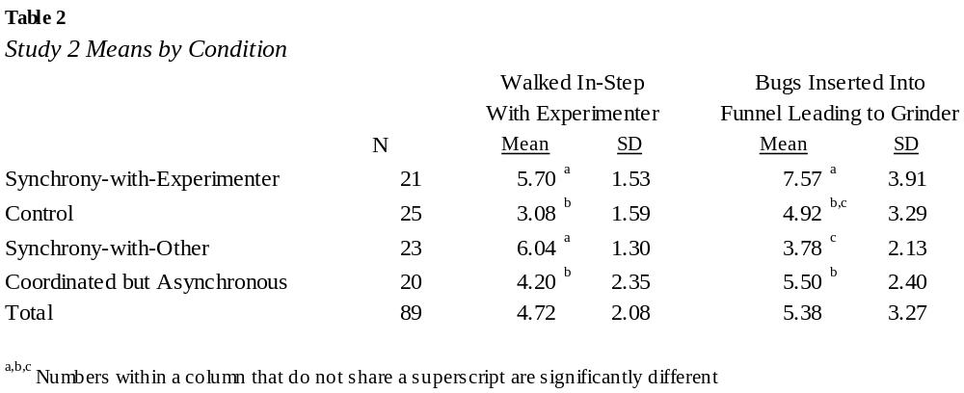
Figure 1: Bug Grinder and Sow Bugs in Cups


