BUAD 310g – Applied Business Statistics

Syllabus – Spring 2017

Professor: | Dr. Phil Rogers | Room: | JFF 105
Office: | Bridge 400E | Office Hours: | Thursday 1:00 PM - 3:50 PM
Email: | phil.rogers@marshall.usc.edu |  | Please email in advance if you would like to meet.

Course Description

In this course, we will focus on learning various statistical techniques and their applications that will assist you in making business decisions. The primary objective of this course is to enable students to perform and understand statistical analysis of data, with the view of being able to critically evaluate statistical reports or findings. You will learn to think critically about how statistics is used by others and how it impacts your day-to-day life and career. No mathematical background beyond high school algebra is required for an understanding of the material.

Course Learning Objectives

You will explore and describe data, examine sampling distributions, make estimations, test hypotheses, perform simple and multiple regression analysis, and build models using extensive software applications both independently and collaboratively.

These applications will guide you to:

- Explain the concepts of descriptive statistics and use sample statistics to make inferences about population characteristics;
- Recognize different models of statistical processes such as hypothesis testing and linear and multiple regression, etc.;
- Explain statistical processes and choose which process to use for particular data analysis applications;
- Learn to interpret statistical results as a basis for decision making;
- Learn to use applicable statistics software;
- Collaborate effectively to use statistical analysis to address business challenges
- Communicate your interpretation of the results of statistical analysis logically and persuasively in speaking and writing
- Become a very proficient user of Excel.

These course level objectives support the six Marshall Program Learning Goals to varying degrees. Details may be found in the Appendix of this syllabus.

Required Materials

The course textbook Applied Statistics in Business and Economics (5th Edition) by David Doane and Lori Seward, is available at the bookstore. You can purchase a hard copy at the book store or an electronic version of the textbook. After you have purchased a book, you must register with McGraw-Hill Connect, which is a website provided by the publisher.

Every student must register with McGraw-Hill’s Connect in order to have access to the homework, which will be administered online. Registration with Connect requires an access code, which you can either purchase online, or get automatically when you buy a new textbook at the USC bookstore. More details are provided on page six below.

Prerequisites and/or Recommended Preparation:

No mathematical background beyond high-school algebra is required.

Course Notes:
The slides for the course and other handouts will be posted on the course Blackboard site. If you would like hard copies of the slides, it will be your responsibility to print them out. Please check the Blackboard site and your email daily for class preparation materials or instructions.

Software:
For the discussions/application sessions, students are required to bring a laptop with Microsoft Excel software. Mac users can use the Mac version of Excel 2016. Mac users can also use the PC version by installing Boot Camp (free from Apple) - or other Windows emulation software for Mac - and Windows. Students can take advantage of the free version of Office 365 that USC provides to students, which includes MS Excel. The free Microsoft USC Office Suite can be downloaded from
http://itservices.usc.edu/officestudents. In addition, the Analysis ToolPak add-in is also required, which can be accessed in the PC environment by clicking on File/Options/Add-ins/Go, checking Analysis ToolPak and clicking OK. The procedure is similar for Macs. Students will be given a free copy of the ExcelNow! tutorial to facilitate their learning of Excel. See the file “Instructions for Downloading the ExcelNow! Tutorial” posted on the Blackboard Content page.

Grading:

Your final grade will be determined as follows:

Component of Grade | % of Grade
Homework * | 10.0%
Application Exercises ** | 10.0%
Application Exam | 22.5%
Midterm Exam | 22.5%
Final Exam | 35.0%
* There are 11 homework assignments, each based on a maximum score of 100% if the assignment is submitted before the due date and time. Late submissions will be accepted, but there will be a deduction of 5% for each day a submission is late. The best 10 scores out of 11 will be used to calculate the average for this component of the course grade.

** There are 11 weeks when application exercises will be due.
The two lowest scores will be dropped when calculating the average for this component of the grade. While accuracy will count, grades will be more a reflection of effort put in than accuracy of the answers.

Class Attendance & Participation:
You are expected to attend all classes. In addition to providing expanded explanations and examples of important statistical analysis concepts, the application sections also present you with the opportunity to pose questions.

The application (discussion) section of the class makes up 32.5% of the course grade. The 32.5% is composed of two parts: (1) There will be 11 application exercises. The lowest two grades will be dropped and the average of the remaining nine scores will count for 10% of the course grade. (2) There will be one exam, done individually, counting for 22.5% of the course grade.

I have no problem going over a concept multiple times. If you feel uneasy bringing up your questions in class, take advantage of the many opportunities to speak with me one-on-one. I am accessible by e-mail, and will be more than happy to speak with you before or after class or during office hours. Note: if your question requires a conversation rather than a short answer, email is not the best way to go – please talk to me after class or during office hours, and I will be happy to answer your question.

Homework:
You will access your assignments and submit the answers online, using McGraw-Hill’s Connect. There will be eleven homework assignments. Due dates for each homework assignment are in the tentative course schedule on page 7. An assignment that is submitted after the due date will have a reduced maximum score as indicated in the footnote on the previous page.

Application Exercises:
You will use Excel for data-analysis and problem solving in the application (discussion) section of this course. The exercises are constructed in order to lead you through key topics introduced in lectures and reading. Your conclusions must explain the quantitative findings through a real-world business perspective. There are no make-up sessions for a missed application session. You must attend only your designated session. You must attend at least nine of the eleven sessions when an application exercise is due. There is no need for a calculator in the application sessions since you will be able to use Excel, which is much more powerful and efficient than a calculator and less prone to errors. Thus, calculators are not allowed in the application sessions.

Midterm Exam, Applications Exam and Final Exam:
The midterm exam will be given in the lecture section of the course on the date announced in the course schedule (page 7). You may bring a single handwritten sheet (both sides) containing formulas to the midterm and you will be allowed two handwritten sheets (both sides) for the final exam. There will also be one individual exam covering the work done in your application sessions. The Application Exam will be in a similar format to the weekly problem-solving applications. No make-ups of tests will be given. You will receive a grade of zero for each missed test unless you have a written excuse from your doctor or the University.

The final examination will take place on Wednesday, May 3, 2017, 8:00-10:00 am for all BUAD 310 sessions. Note that it is an exception final, as it does not take place at the regularly listed time. The final exam is comprehensive (this is inevitable in a Statistics course) but greater emphasis will be given to the material taught later in the semester. You cannot be exempted from this final under any circumstances. The final exam will NOT be given at any other time.

Note that according to the USC Office of Academic Records and Registrar, “No student in a course with a final examination is permitted to omit the final examination or take the final examination prior to its scheduled date, and no instructor is authorized to permit a student to do so. No student is allowed to re-take a final examination or do extra work in a course after the semester has ended for purposes of improving his or her grade.”

Collaboration Policy:
Discussion of homework problems is permitted and encouraged; however, each student is required to prepare and submit his or her solutions, including computer work, independently. Collaboration of any sort on tests and exams is prohibited and will result in a 0 on that exam. I reserve the right to bring any potential cheating issues to the administration for further penalties.

MARSHALL GUIDELINES

Add/Drop Process:
The last day to register and add classes is January 27, 2017. The last day to drop a class without a mark of “W” is also January 27, 2017. For more information, visit
https://classes.usc.edu/term-20171/calendar/
Academic Conduct:
Academic Integrity and Conduct
USC seeks to maintain an optimal learning environment. General principles of academic honesty include the concept of respect for the intellectual property of others, the expectation that individual work will be submitted unless otherwise allowed by an instructor, and the obligations both to protect one’s own academic work from misuse by others as well as to avoid using another’s work as one’s own (plagiarism). Plagiarism – presenting someone else’s ideas as your own, either verbatim or recast in your own words – is a serious academic offense with serious consequences. All students are expected to understand and abide by the principles discussed in the SCampus, the Student Guidebook (www.usc.edu/scampus or http://scampus.usc.edu). A discussion of plagiarism appears in the University Student Conduct Code (section 11.00 and Appendix A).

Students will be referred to the Office of Student Judicial Affairs and Community Standards for further review, should there be any suspicion of academic dishonesty. The Review process can be found at: http://www.usc.edu/student-affairs/SJACS/ . Failure to adhere to the academic conduct standards set forth by these guidelines and our programs will not be tolerated by the USC Marshall community and can lead to dismissal.

Discrimination, sexual assault, and harassment are not tolerated by the university. You are encouraged to report any incidents to the Office of Equity and Diversity http://equity.usc.edu or to the Department of Public Safety http://adminopsnet.usc.edu/department/department-public-safety. This is important for the safety of the whole USC community. Another member of the university community – such as a friend, classmate, advisor, or faculty member – can help initiate the report, or can initiate the report on behalf of another person. The Center for Women and Men http://www.usc.edu/student-affairs/cwm/ provides 24/7 confidential support, and the sexual assault resource center webpage http://sarc.usc.edu describes reporting options and other resources.

Support Systems:
Students whose primary language is not English should check with the American Language Institute http://dornsife.usc.edu/ali, which sponsors courses and workshops specifically for international graduate students. The Office of Disability Services and Programs (www.usc.edu/disability) provides certification for students with disabilities and helps arrange the relevant accommodations. If an officially declared emergency makes travel to campus infeasible, USC Emergency Information (http://emergency.usc.edu/) will provide safety and other updates, including ways in which instruction will be continued by means of blackboard, teleconferencing, and other technology.

Students need to make a request with Disability Services and Programs (DSP) for each academic term that accommodations are desired. A letter of verification for approved accommodations can be obtained from DSP. Please be sure the letter is delivered to me as early in the semester as possible. DSP is located in STU 301 and is open 8:30 a.m.–5:00 p.m., Monday through Friday. The phone number for DSP is (213) 740-0776. Students requesting test-related accommodations will need to share and discuss their DSP recommended accommodation letter/s with their faculty and/or appropriate departmental contact person at least three weeks before the date the accommodations will be needed. Additional time may be needed for final exams. Reasonable exceptions will be considered during the first three weeks of the semester as well as for temporary injuries and for students recently diagnosed. Please note that a reasonable period of time is still required for DSP to review documentation and to make a determination whether a requested accommodation will be appropriate.

Class Notes Policy:

Notes or recordings made by students based on a university class or lecture may only be made for purposes of individual or group study, or for other non-commercial purposes that reasonably arise from the student’s membership in the class or attendance at the university. This restriction also applies to any information distributed, disseminated or in any way displayed for use in relationship to the class, whether obtained in class, via email or otherwise on the Internet, or via any other medium. Actions in violation of this policy constitute a violation of the Student Conduct Code, and may subject an individual or entity to university discipline and/or legal proceedings.

Emergency Preparedness/Course Continuity:

In case of a declared emergency if travel to campus is not feasible, USC executive leadership will announce an electronic way for instructors to teach students in their residence halls or homes using a combination of Blackboard, teleconferencing, and other technologies.

McGraw-Hill’s Connect

McGraw Hill’s Connect is an online learning system where you can:
- Access two electronic versions of your textbook – a static eText that you can annotate and highlight, and an adaptive reading experience with personalized quizzes, called SmartBook.
- Complete homework assignments and practice assignments directly from your textbook, complete with tutorial videos, guides, and additional resources.
- Study more efficiently with a personalized study plan and exercises that match your book.

Before You Begin:
To register for Connect, you need:
- A Connect student access code (packaged with your new text at the bookstore, or available for purchase with a major credit card when registering)
- Access to your BUAD 310 course in Blackboard
- A valid email address

Student Registration:
      - Go to your BUAD 310 course in Blackboard.
      - In your course home page, go to the page where your instructor has posted Connect assignments (sometimes under the “Content” or “Assignments” folder).
      - Click on your first Connect assignment to begin registration for Connect.
      - If you already have a Connect account, enter your email address and click “Sign In.” New to Connect? Click “Register.”
      - Registration options-
  - Connect Student Access Code - bundled with the package at the bookstore.
  - Purchase Connect directly online - Allows full access to Connect and SmartBook/LearnSmart.
  - Get courtesy access – Two-week full Connect access.
      - Create your McGraw-Hill Connect Account and Complete Your Registration.

Once your registration is complete, a Confirmation page appears. You will also receive this information by email. You are now ready to access your resources!

To access your Connect assignments:
- Click on any Connect assignment from within your Blackboard course.
- Connect with automatically open directly to that assignment. Once you complete an assignment and select “Submit,” your grade will automatically flow to your Blackboard grade book.
- Always access your Connect assignments through Blackboard! If you access directly through McGraw-Hill, your grades may not sync over.

Tech Support & FAQ:
Call: (800) 331-5094
Email & Chat: www.mhhe.com/support
Monday - Thursday ● 7 AM - 3 AM
Friday ● 7 AM - 8 PM
Saturday ● 9 AM - 7 PM
Sunday ● 11 AM – 1 AM
(All times Central)

Training & Tutorials:
connectstudentsuccess.com

The schedule below shows the topics covered each week in lecture and the corresponding reading assignments from the text book. The sections in the reading assignments include some topics that you are not responsible for. These topics are indicated in the Exclusions column. The reading must be done in Connect and completed by 11:59 PM of the second Sunday after the topic is covered in lecture. For example, if Probability: Basic Concepts is covered in lecture on Tuesday, January 24, Sections 5.1 to 5.5 of the book (not including the topics listed in the Exclusions column) must be read by the end of the day Sunday, February 4.
The schedule for the Application (discussion) sessions is on the next page. The schedule of lectures might be revised slightly during the semester, but the dates for the Midterm, Application and Final exams are fixed.

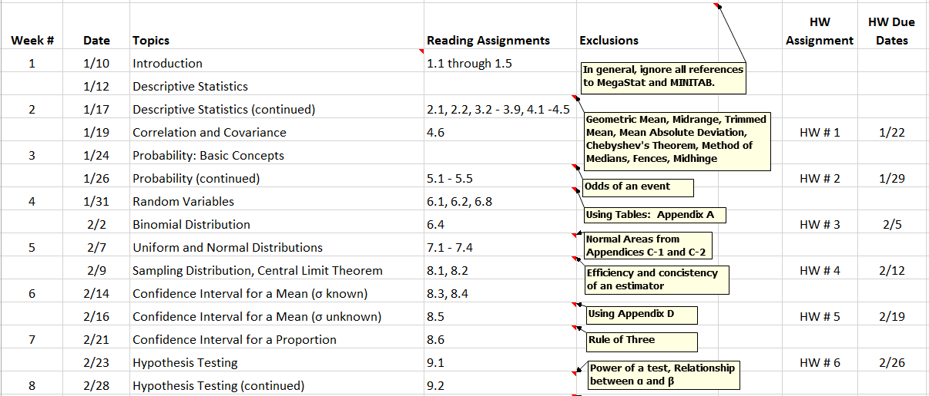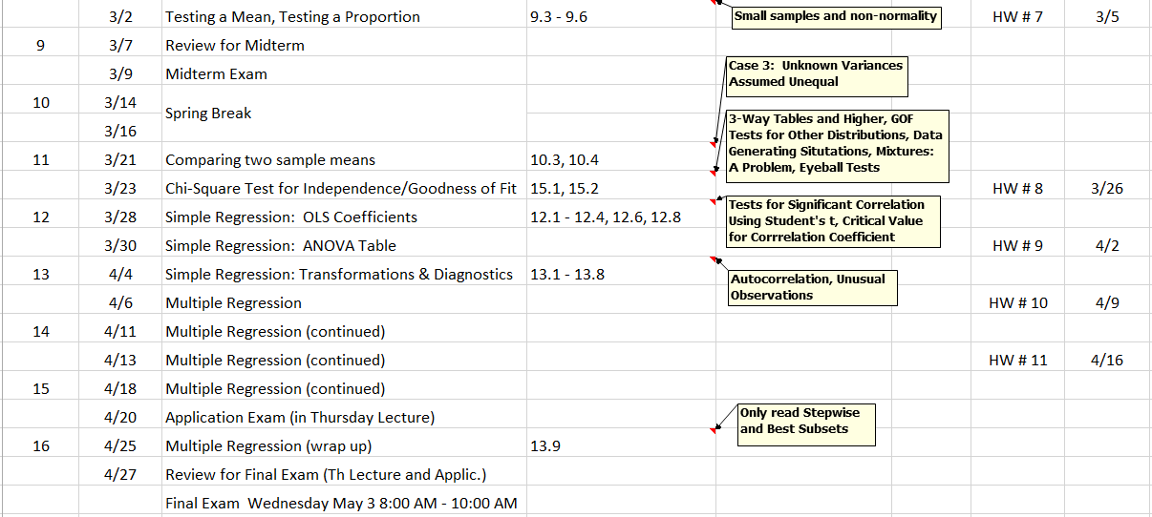

The schedule of Application (discussion) sessions is shown below.

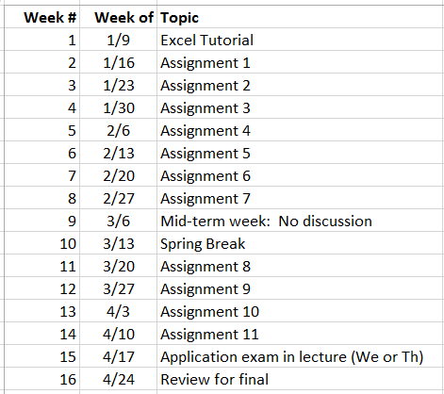

APPENDIX

Contribution of BUAD310 Applied Business Statistics to Student Achievement of
Marshall’s Six Undergraduate Program Learning Goals
 | # |  | Marshall Program Learning Goal Description |  | Degree of Emphasis |  | BUAD310 Course Objectives that Support This Marshall Undergraduate Goal
 | 1 |  | Our graduates will understand types of markets and key business areas and their interaction to effectively manage different types of enterprises.  Specifically, students will: |  | Low |  | BUAD310 Course Objectives 1-7 support Goal 1
 | 1.1 |  | Demonstrate foundational knowledge of core business disciplines, including business analytics and business economics. |  |  |  | 1. Understand the concepts of descriptive statistics, inference, summarizing, and sampling  2.Recognize different models of statistical processes  3.Explain statistical processes and choose which to use for particular data analysis applications  4.Learn to interpret statistical results as a basis for decision-making;  5.Learn to use applicable statistics software;  6.Collaborate effectively to use statistical analysis to address business challenges  7.Communicate results of statistical analysis logically and persuasively
 | 1.2 |  | Understand the interrelationships between functional areas of business so as to develop a general perspective on business management. |  |  |  | 1. Understand the concepts of descriptive statistics, inference, summarizing, and sampling  4.Learn to interpret statistical results as a basis for decision-making;  6.Collaborate effectively to use statistical analysis to address business challenges  7.Communicate results of statistical analysis logically and persuasively
 | 1.3 |  | Apply theories, models, and frameworks to analyze relevant markets (e.g. product, capital, commodity, and factor and labor markets). |  |  |  | 1. Understand the concepts of descriptive statistics, inference, summarizing, and sampling  2.Recognize different models of statistical processes  3.Explain statistical processes and choose which to use for particular data analysis applications  4.Learn to interpret statistical results as a basis for decision-making;  5.Learn to use applicable statistics software  6.Collaborate effectively to use statistical analysis to address business challenges  7.Communicate results of statistical analysis logically and persuasively
 | 1.4 |  | Show the ability to utilize technologies (e.g., spreadsheets, databases, software) relevant to contemporary business practices. |  |  |  | 5.Learn to use applicable statistics software;  6.Collaborate effectively to use statistical analysis to address business challenges
 | 2 |  | Our graduates will develop a global business perspective. They will understand how local, regional, and international markets, and economic, social and cultural issues impact business decisions so as to anticipate new opportunities in any marketplace. Specifically, students will: |  | Low |  | BUAD310 Course Objectives 6-7 support Goal 2
 | 2.1 |  | Understand how local, regional and global markets interact and are impacted by economic, social and cultural factors. |  |  |  | 6.Collaborate effectively to use statistical analysis to address business challenges
 | 2.2 |  | Understand that stakeholders, stakeholder interests, business environments (legal, regulatory, competitor) and business practices vary across regions of the world. |  |  |  | 6.Collaborate effectively to use statistical analysis to address business challenges  7.Communicate results of statistical analysis logically and persuasively
 | 3 |  | Our graduates will demonstrate critical thinking skills so as to become future-oriented decision makers, problem solvers and innovators. Specifically, students will: |  | High |  | BUAD310 Course Objectives 1-7 support Goal 3
3.1 |  | Understand the concepts of critical thinking, entrepreneurial thinking and creative thinking as drivers of innovative ideas. |  |  |  | 3.Explain statistical processes and choose which to use for particular data analysis applications  4.Learn to interpret statistical results as a basis for decision-making;  6.Collaborate effectively to use statistical analysis to address business challenges  7.Communicate results of statistical analysis logically and persuasively
3.2 |  | Critically analyze concepts, theories and processes by stating them in their own words, understanding key components, identifying assumptions, indicating how they are similar to and different from others and translating them to the real world. |  |  |  | 3.Explain statistical processes and choose which to use for particular data analysis applications  4.Learn to interpret statistical results as a basis for decision-making;  6.Collaborate effectively to use statistical analysis to address business challenges  7.Communicate results of statistical analysis logically and persuasively
3.3 |  | Be effective at gathering, storing, and using qualitative and quantitative data and at using analytical tools and frameworks to understand and solve business problems. |  |  |  | 1. Understand the concepts of descriptive statistics, inference, summarizing, and sampling  2.Recognize different models of statistical processes  3.Explain statistical processes and choose which to use for particular data analysis applications  4.Learn to interpret statistical results as a basis for decision-making;  5.Learn to use applicable statistics software;  6.Collaborate effectively to use statistical analysis to address business challenges  7.Communicate results of statistical analysis logically and persuasively
3.4 |  | Demonstrate the ability to anticipate, identify and solve business problems. They will be able to identify and assess central problems, identify and evaluate potential solutions, and translate a chosen solution to an implementation plan that considers future contingencies |  |  |  | 6.Collaborate effectively to use statistical analysis to address business challenges  7.Communicate results of statistical analysis logically and persuasively
4 |  | Our graduates will develop people and leadership skills to promote their effectiveness as business managers and leaders. Specifically, students will: |  | Low |  | .  BUAD310 Course Objectives 3,4,6-7 support Goal 4
4.1 |  | Recognize, understand, and analyze the motivations and behaviors of stakeholders inside and outside organizations (e.g., teams, departments, consumers, investors, auditors). |  |  |  | 6.Collaborate effectively to use statistical analysis to address business challenges  7.Communicate results of statistical analysis logically and persuasively
4.2 |  | Recognize, understand and analyze the roles, responsibilities and behaviors of effective managers and leaders in diverse business contexts e.g., marketing, finance, accounting. |  |  |  | 3.Explain statistical processes and choose which to use for particular data analysis applications  4.Learn to interpret statistical results as a basis for decision-making  6.Collaborate effectively to use statistical analysis to address business challenges  7.Communicate results of statistical analysis logically and persuasively
4.3 |  | Understand factors that contribute to effective teamwork. |  |  |  | 6.Collaborate effectively to use statistical analysis to address business challenges  7.Communicate results of statistical analysis logically and persuasively
5 |  | Our graduates will demonstrate ethical reasoning skills, understand social, civic, and professional responsibilities and aspire to add value to society. Specifically, students will: |  | Low |  | BUAD310 Course Objectives 1-4,6-7 support Goal 5
5.1 |  | Understand professional codes of conduct. |  |  |  | 1. Understand the concepts of descriptive statistics, inference, summarizing, and sampling  2.Recognize different models of statistical processes  3.Explain statistical processes and choose which to use for particular data analysis applications  4.Learn to interpret statistical results as a basis for decision-making;  6.Collaborate effectively to use statistical analysis to address business challenges  7.Communicate results of statistical analysis logically and persuasively
5.2 |  | Recognize ethical challenges in business situations and assess appropriate courses of action. |  |  |  | 1. Understand the concepts of descriptive statistics, inference, summarizing, and sampling  3.Explain statistical processes and choose which to use for particular data analysis applications  4.Learn to interpret statistical results as a basis for decision-making  6.Collaborate effectively to use statistical analysis to address business challenges  7.Communicate results of statistical analysis logically and persuasively
6 |  | Our graduates will be effective communicators to facilitate information flow in organizational, social, and intercultural contexts. Specifically, students will: |  | Low |  | BUAD310 Course Objectives 4,6,7 support Goal 6
6.1 |  | Identify and assess diverse personal and organizational communication goals and audience information needs |  |  |  | 4.Learn to interpret statistical results as a basis for decision-making;  6.Collaborate effectively to use statistical analysis to address business challenges  7.Communicate results of statistical analysis logically and persuasively
6.2 |  | Understand individual and group communications patterns and dynamics in organizations and other professional contexts |  |  |  | 4.Learn to interpret statistical results as a basis for decision-making;  6.Collaborate effectively to use statistical analysis to address business challenges  7.Communicate results of statistical analysis logically and persuasively
6.3 |  | Demonstrate an ability to gather and disseminate information and communicate it clearly, logically, and persuasively in professional contexts. |  |  |  | 6.Collaborate effectively to use statistical analysis to address business challenges  7.Communicate results of statistical analysis logically and persuasively

