Price Inflation and Wealth Transfer during
the 2008 SEC Short-Sale Ban

Lawrence E. Harris
Ethan Namvar
Blake Phillips∗

ABSTRACT

Using a factor-analytic model that extracts common valuation information from the prices of stocks that were not banned, we estimate that the ban on short-selling financial stocks imposed by the SEC in September 2008 led to substantial price inflation in the banned stocks. For stocks experiencing negative performance prior to the ban, the inflation reversed approximately two weeks following the ban. Although stocks with positive pre-ban performance where estimated to have realized a similar magnitude of inflation during the ban, we find little evidence of a post-ban reversal for this subset of stocks. The reversal evidence suggests the effects of the short-sale ban may have been limited to stocks with negative price pressure prior to the ban. Other factors such as the pending TARP legislation may also have affected prices, though our results suggest that it was not a significant factor. If prices were inflated, buyers paid more than they otherwise would have paid for the banned stocks during the period of the ban. We provide an estimate of $2.3 to $4.9 billion for the resulting wealth transfer from buyers to sellers, depending on how post-ban reversal evidence is interpreted. Such transfers should interest policymakers concerned with maintaining fair markets.

Keywords: Short-sale Ban, SEC, Securities and Exchange Commission, Short-Sale Constraints, Financial Crisis.

JEL Codes: G12, G14, G18, G28

Price Inflation and Wealth Transfer during
the 2008 SEC Short-Sale Ban

ABSTRACT

Using a factor-analytic model that extracts common valuation information from the prices of stocks that were not banned, we estimate that the ban on short-selling financial stocks imposed by the SEC in September 2008 led to substantial price inflation in the banned stocks. For stocks experiencing negative performance prior to the ban, the inflation reversed approximately two weeks following the ban. Although stocks with positive pre-ban performance where estimated to have realized a similar magnitude of inflation during the ban, we find little evidence of a post-ban reversal for this subset of stocks. The reversal evidence suggests the effects of the short-sale ban may have been limited to stocks with negative price pressure prior to the ban. Other factors such as the pending TARP legislation may also have affected prices, though our results suggest that it was not a significant factor. If prices were inflated, buyers paid more than they otherwise would have paid for the banned stocks during the period of the ban. We provide an estimate of $2.3 to $4.9 billion for the resulting wealth transfer from buyers to sellers, depending on how post-ban reversal evidence is interpreted. Such transfers should interest policymakers concerned with maintaining fair markets.

Beginning in the summer of 2008, the U.S. Securities and Exchange Commission (SEC) implemented a series of short-sale restrictions that had several intended and likely unintended consequences. This paper examines the effects of the absolute ban on short-selling financial sector stocks imposed by the SEC in September, 2008.
The SEC was concerned that short-sellers were manipulating (or could manipulate) the stock prices of financial firms which were facing strong, downward price pressure due to the global financial crisis. In particular, the commissioners feared that stock price decreases might convince depositors and other creditors that the firms were in financial distress and facing significant bankruptcy risk. With such convictions, many creditors would withdraw deposits and other short-term credit facilities, which would force the firms to sell their long positions under duress. The associated liquidation costs would further lower stock prices. These liquidity death spirals could lead to bankruptcies and substantial profits for short-sellers. The SEC banned short-selling to mitigate concerns about sentiment driven liquidity death spirals contributing to lowering stock prices and firm financial distress.
We may never know whether short-sellers were indeed manipulating prices to create liquidity death spirals. When confronted, short-sellers invariably defend their actions as motivated by stock valuation (selling short overvalued stocks) as opposed to market manipulation objectives. Given the extreme losses that many financial firms experienced in real estate and other securities, this argument is credible.
If financial stocks were indeed overvalued, or if they were merely properly valued before the ban, the ban on short-selling had a potentially serious unintended consequence. By preventing short-sellers from trading, the SEC created a bias toward higher prices. The unintended consequence of this bias is that buyers could have bought at prices above fundamental value. If so, these buyers would face significant loses when prices ultimately adjust downward to their true intrinsic values.
Anecdotal evidence suggests that this scenario may indeed have occurred. Before the September, 2008 ban on short-selling, Freddie Mac (FRE) and Fannie Mae (FNM) common shares were trading near 30 cents and 50 cents, respectively. During the ban, their shares rose to nearly $2.00 per share. Following the end of the ban, the share prices of both firms soon returned to approximately 60 cents per share. If the ban inflated FRE and FNM share prices by preventing short-sellers from supplying liquidity to an imbalance of buyers, then buyers traded at artificially high prices. For long sellers, the ban on short-selling provided an unexpected windfall. We estimate that during the period of the ban, inflation may have transferred $597M from buyers to sellers in the shares of FRE and FNM.
This paper examines the prices of the common stocks that were subject to the SEC short-sale ban to estimate the price inflation, if any, associated with the ban. Using a factor-analytic model, we provide conservative estimates of the inflation. Our estimates are based on the assumption that we can extract meaningful information about the values of the banned stocks from an analysis of the prices of the non-banned stocks.
We recognize that the banned stock values may depend on factors that we could not model so that the inflation we estimate may be due to other factors besides the SEC ban. Foremost among these other factors may have been valuation effects associated with the Troubled Asset Repurchase Program (TARP) legislation that Congress was debating during the period of the ban. If such factors did not also affect the non-banned stocks, the inflation we estimate may not have been due to the short-selling ban. We specifically address the possibility that optimism about TARP inflated the banned stock prices. Our results suggest that concerns about the TARP do not account for the results. We are also able to exclude the potential bias of simultaneous events by examining the post-ban reversal of estimated inflation. Given the short duration of the short-sale ban, the resulting inflation should be transitory and reverse following the ban. In contrast, valuation effects associated with other potentially confounding events should be more permanent in nature and be followed by limited reversals.
Our results suggest that during the 14 trading day short-sale ban the stock prices of financial sector firms were inflated by approximately 10-12%, depending on the weights used to compute benchmark returns. For the sub-sample of stocks with more negative returns before the ban, inflation resulting from the ban is corrected approximately 2 weeks later. Although we do note a similar magnitude of inflation for stocks with positive pre-ban performance, we find little evidence of a post-ban correction for this subset of stocks. Our ability to relate the estimated inflation to the short-sale ban is dependent in part on the identification of a post-ban reversal of inflation. Thus, the reversal evidence suggests that the effects of the short-sale ban may potentially have been limited to stocks with negative pre-ban performance.
We find that the price inflation is lower for stocks with greater short interest before the ban. We suspect that the ban had less effect on these stocks because the market was not concerned about further short-selling of high short interest stocks. Since these highly shorted stocks would most likely have benefited from the TARP, this evidence also suggests that a TARP factor does not account for all of the inflation. We also find evidence that price inflation is strongest for stocks for which no listed options trade. The SEC excluded option dealers from the short-sale ban, thus they were able to hedge put option exposure via short-sales, which permitted their customers to form synthetic, short positions. Our results suggest that options provided an effective substitute for direct short-sales during the ban and providing further evidence that the inflation we document is related to the short-sale ban. Consequently, the options exchanges benefited from the ban via increased transactions revenue.
Depending on how the reversal evidence is interpreted, we estimate that buyers transferred $2.3 to $4.9 billion more to sellers due to the inflation in the banned stocks during the ban period than they would have had the SEC not imposed the ban. This estimate assumes that the inflation was not due to concerns about the pending TARP legislation or other events coinciding with the short-sale ban. For reasons discussed below, we believe that this estimate is conservative.
Our study is related to a recent study by Boehmer, Jones, and Zhang (2008). They examine the changes in stock prices, the rate of short-sales, the aggressiveness of short-sellers, and various liquidity measures before, during, and after the short-sale ban period. Focusing on a subset of the banned sample, they find that share prices for banned stocks appeared to be inflated relative to the non-banned control, and shorting activity dropped by about 85%. They also find that liquidity as measured by spreads, price impacts, and intraday volatility significantly decreased during the period of the ban.
Our study differs from Boehmer, Jones, and Zhang (2008) in two important respects. First, we provide a more sophisticated model of what prices would have been for the banned stocks had the ban not been enacted. Boehmer et al. use a sample of stocks that were not banned as a benchmark control sample. They thus implicitly assume that the banned and the non-banned stocks in aggregate shared similar characteristics other than inclusion on the ban list. In contrast, we estimate a factor-analytic model that uses stock-level loadings on risk factors common across both banned and non-banned samples to disentangle the effects of the ban from other effects that may have been due to the global financial crisis or to other valuation factors. This issue is very important because both studies are essentially one-shot event studies for which the results depend critically on the estimates of what prices would have been if the ban had not occurred. The estimation model must produce accurate estimates of these prices; otherwise the conclusions will not be credible. Second, we provide direct estimates of the magnitude and cost of the inflation to buyers. This calculation is of obvious importance to the debate about whether the ban was sensible.
We organized the remainder of this paper as follows. Section I provides an overview of the related literature. We describe the data used in the analysis in Section II, and introduce our analytic methods in Section III. Our inflation estimation results appear Section IV, and our analysis of post-ban reversals and wealth transfers between buyers and sellers appears in Section V. Finally, we conclude in Section VI.

I. Literature Review

The effect of short-sale constraints on market efficiency is well documented in the finance literature. Early theoretical work by Miller (1977) argued that short-sale constraints exclude pessimistic investors from the market. Thus, a subset of value opinions are excluded from the cross-section of opinions which converge to form prices, resulting in an upward, optimism bias in short-sale constrained stock prices. Diamond and Verrecchia (1987) extended the theoretical work of Miller, arguing in a rational framework that option introduction provides the opportunity for pessimistic investors to realize synthetic, short positions, potentially mitigating short-sale constraints. They argue that options thus allow the incorporation of negative information into stock prices more rapidly, moving markets closer to strong form efficiency.
In aggregate, the majority of empirical analysis finds that short-sale constraints contribute to overpricing and a reduction in market quality and efficiency. Our research relates most strongly to the literature focusing on aggregate market effects of short-selling and short-sale constraints. For example, Bris, Goetzmann, and Zhu (2007) consider whether short-sale restrictions may be helpful during severe market panics. They analyze cross-sectional and time series information from forty-six equity markets and find that short-sale restrictions do not have noticeable affects at the individual stock level. On the other hand, they find that markets with active short-sellers are informationally more efficient than those markets without significant short-selling.
Charoenrook and Daouk (2005) examine 111 countries to determine the effect of market-wide short-sale restrictions on value-weighted market returns obtained from DataStream. They find that index returns are less volatile and markets are more liquid when short-sales are allowed. They thus conclude that the ability to short-sell substantially improves market quality. Further, they find no evidence that short-sale restrictions affect the probability of a market crash.
Looking at the relationship between short-sale constraints and options, Phillips (2008) investigates the differential effect of the 2008 short-sale ban on optionable and non-optionable stocks. Phillips finds that, after controlling for financial sector exposure and a range of stock characteristics, negative information was incorporated more freely into optionable stocks during the ban. His results suggest that put options acted as an effective substitute for short-sales during the ban and thus the effect of the ban, if any, was likely significantly less for optionable stocks. These results are complementary to our results.
A small literature has recently emerged which examines actions by the SEC to mitigate the effect of short-sales on the market, both in general and during the 2008 short-sale ban. Boulton and Braga-Alves (2008) analyze the 2008 SEC ban on naked short-sales. Although they examine the stocks of only 19 financial firms, they find that the ban had an adverse affect on liquidity and price informativeness. As mentioned previously, Boehmer, Jones, and Zhang (2008) also examine the short-sale ban of 2008 and find that the ban decreased market quality as measured by spreads, price impacts, and intraday volatility. Our study differs from theirs in that we primarily examine the price inflation and its implications whereas Boehmer, Jones, and Zhang focus more on other aspects of market quality.

II. Data

Our sample includes all stocks listed on the New York (NYSE), the American (AMEX) and the National Association of Securities Dealers Automated Quotations (NASDAQ) stock exchanges between September 18, 2007 and December 31, 2008. We divided the sample into three sub-periods: the pre-ban period (September 18, 2007 to September 18, 2008), the ban period (September 19 to October 8, 2008), and the post-ban period (October 9 to December 31, 2008). In total, the SEC placed 987 stocks the banned list, 88% of which were included on the original list released on September 19. An additional 10% were added on September 22 and 23, and the remaining 2% were added between September 24 and as late as October 7.
We obtained stock price, volume, and shares outstanding data from the Center for Research in Security Prices (CRSP) database, and short interest data from the Short Squeeze database. The CRSP dataset includes 7,639 stocks in our sample period. We exclude all stocks with an incomplete data record (1,733 securities), all stocks with market capitalization less than $50 million on September 18, 2008 (1,067 securities), and all stocks for which trading volume exceeded five times shares outstanding on any given day in the sample (5 securities). We also exclude stocks for which inclusion on the SEC short-sale ban list is ambiguous, including stocks added and subsequently deleted at the request of the firm (10 stocks), or stocks added after September 26, 2008 (10 stocks). Finally, we exclude 4 stocks for which short interest data are missing from the Short Squeeze database. The resulting sample includes 4,810 stocks, 676 of which appeared on the SEC ban list. Between October 28, 2008 and December 31, 2008, 127 of the 676 banned stocks received TARP funds. The returns analyzed in this study are dividend- and split-adjusted log price relatives.

[Insert Figure 1 approximately here]
Panel A of Figure 1 plots various cumulative return indices over the 15 month sample period. Value-weighted indices of the non-banned and banned stocks indicate that these two subsamples lost 8% and 30% of value, respectively, during the year before the ban (the pre-ban period). These average losses increased during the ban period, with non-banned and banned stocks losing an additional 18% and 14% of market value, respectively, during the 14-trading day ban. By December 31, 2008, non-banned and banned stocks had realized cumulative losses of 32% and 54%, respectively, over the prior 15 months. The losses were greater for banned stocks for which a substantial fraction of their float was sold short as of September 15, 2008. Over the entire sample period, the short interest-weighted banned index lost 67% of market value.
Panel A of Figure 1 also plots a cumulative return index for banned stocks that subsequently received TARP funds in 2008. (All stocks that subsequently received TARP funds in 2008 were on the SEC banned short-sale list.) The return to each stock in the TARP index are weighted by the fraction of its October 28, 2008 common stock market capitalization that it received in TARP funds. This index thus reflects the returns of those stocks for which the TARP funds subsequently proved to be largest relative to their common stock capitalization. The TARP index decreased by 68% over our sample period.
Panel B of Figure 1 compares cumulative value-weighted indices for the banned subsample separately for stocks that subsequently received TARP funds in 2008 and for those that did not. Not surprisingly, the TARP stocks realized 9% greater cumulative losses than the other banned stocks (-61% versus -52%, respectively) as the companies that received TARP funds were more financially distressed, on average, than those that did not.

[Insert Figure 2 approximately here]

Figure 2 reports bi-monthly, mean short interest for the non-banned and banned stocks in 2008. The reported means are weighted by market capitalization (Panel A) and by the fraction of float sold short on September 15, 2008 (Panel B) to make the results comparable to the corresponding value and short interest-weighted index return results shown in Figure 1.
Both weighting methods produce similar results. From January through June, short interest gradually increased for both banned and non-banned stocks. Short interest then rapidly declined in the second half of the year as short-sellers closed positions. Several processes explain these results. On the demand side, short-sellers may have believed prices had run their course and covered their positions. Financing issues may have also caused them to reduce their leverage. On the supply side, stock lenders concerned about the integrity of their collateral funds were withdrawing shares from the lending market as were those lenders who were selling stock. The short-sale ban, of course, also contributed to the decline in short interest following its imposition.
The results in Figures 1 and 2 reflect a period of rapid decline in security values during the global financial crisis. The banned stocks, which were primarily financial sector stocks, realized the greatest losses. Among these, those that subsequently received TARP funds, on average, declined the most. Short selling in stocks for which short interest was highest on September 15, 2008 had already declined substantially before the ban, suggesting short-sellers of these stocks had already profited substantially earlier in the year.
Visual inspection of the cumulative index returns in Figure 1 suggests that the short-sale ban had a limited effect on arresting the decline in value of the banned (primarily financial sector) stocks. Stock value declines during the ban, for both non-banned and banned stocks, were more rapid than any other equivalent time span in the pre- or post-ban periods. The remainder of this paper examines prices during and around the ban period in greater detail.

III. The Factor-Analytic Model

We use a factor-analytic approach to estimate the market values that would have been observed for the banned stocks had the SEC not imposed the short-sale ban. To do so, we use the information in the prices of the non-banned stock returns to project returns for the banned stocks. Our method is a two-stage process. In the first stage, for each stock, over the year before the short-sale ban (September 18, 2007 to September 18, 2008), we estimate factor loadings associated with the three Fama-French factors (Fama and French, 1993), the momentum factor (Carhart, 1997), the value-weighted banned stock index, and the TARP index using the following time-series regression:

(1)

where r_{i,t} is the dividend- and split-adjusted log price relative for stock i on day t. ExMkt, SMB, HML, and MOM are the Fama-French and momentum factors on day t, BAN is the value- weighted return to the banned stocks on day t, and TARP is the TARP-weighted return to the banned stocks on day t. This regression identifies factor loadings for six market-based risk factors for each stock in the sample.
Factor loadings on the variable Ban will help identify the performance of the banned stocks. Those on the variable TARP will help identify the effect, if any, optimism about the passage of the TARP legislation may have had on the banned stock returns.
In the second stage, we estimate a cross-sectional return model for each day in the sample period utilizing the market-based risk factor loadings from the first stage as regressors. In addition, we also include three stock characteristics—inverse price, turnover, and volatility—to better identify how stock prices varied in the cross-section. Our cross-sectional model is given by:
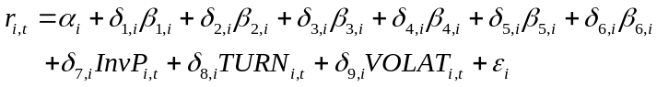 (2)
where r_{i,t} and β₁ through β₆ are as described above and InvP is the daily inverse price, TURN is aggregate trading volume over the previous ten trading days divided by shares outstanding, and VOLAT is the root mean squared return over the previous ten trading days.
We estimate this factor model using only the non-banned stocks. We weight the cross-sectional model by value (market capitalization) to give greater weight to stocks which we believe market prices are most accurate and which are economically most significant. The coefficients are estimates of the realized factor returns associated with each of the regressors, based only on information in the returns to the non-banned stocks. We then use these factor estimates to obtain predicted daily returns for the banned stocks based upon their cross-sectional characteristics. Finally, we aggregate the daily return estimates for each banned stock to produce a value-weighted index of the prices that we estimate would have been observed had the ban not been in place.
To identify the predictive power of the factor-analytic model, we examine the accuracy of the model’s return predictions for the banned stock subsample in the pre-ban and post-ban periods (the year before the ban and the period between the end of the ban and the end of 2008). We use three methods to measure predictive accuracy: (1) the correlation between estimated and actual mean returns, (2) paired t-tests between mean estimated and actual daily returns, and (3) the correlation between actual factor return values and those estimated with Equation 2.
We examined these measures for four different specifications of our basic model. We considered different specifications to determine to what extent our results depend on our assumptions, and to try to find a parsimonious model that could accurately estimate stock returns in the absence of the short-sale ban. In addition to the full cross-sectional model described above, we also examine a model with only three return factors (market, banned stock and TARP) and all three stock characteristics (inverse price, turnover, and volatility), a model with the six return factors (Fama-French, momentum, banned stock and TARP) with no stock characteristics, and a model with only three return factors and no stock characteristics. For those cross-sectional models that only use three return factors, we obtained their factor loadings from time-series regressions that included only those three factors.

[Insert Table I approximately here]

All four models perform well based on our three accuracy measures (Table I). During the year before the ban, the correlation between the actual and estimated daily value-weighted banned stock index returns (based the factor returns implied from the non-banned stocks) is above 0.92 for the two models with three return factors and above 0.98 for the two models with six return factors. Inclusion of the three stock characteristics does not appreciably increase these correlations.
The means of the daily actual and estimated banned stock index returns in the pre-ban period are statistically indistinguishable for all four model specifications (t-statistics for the paired t-test range from 0.06 to 0.47). These results indicate that our methods are not producing significant drift in the return estimates that would bias our return inflation estimates.
The daily cross-sectional regressions estimate factor returns for the six return factors and for the three cross-sectional characteristic factors. Panel B of Table I presents correlations between the daily estimates of the six return factors and their corresponding actual factor values. These correlations are all above 0.90 in the pre-ban period, with the most critical factors (market, banned stock index, and TARP) all above 0.96 for the six return factor models. The correlations are lower for the three factor models, which suggest that the additional factor structure increases the estimation accuracy. The addition of the three stock characteristic factors doesn’t appreciably affect the estimation of the return factor values, most probably because they convey orthogonal information. These correlations are all lower—though still generally quite high—in the post-ban period, probably due to greater volatility and possibly to the smaller sample period.
The evidence from these analyses suggests that the six return, three stock characteristic factor model (as described in Equations 1 and 2) is the most accurate model of the four models. We use it for the remainder of the paper. Visual evidence of the high correlation between the actual and estimated banned index returns appears in Figure 3, which plots cumulatives of the actual index and of the estimated index for the year before the ban.

[Insert Figure 3 approximately here]

The root mean squared difference between the actual and estimated banned stock index returns in the year before the ban is 0.20%, and the first order autocorrelation of these differences is 0.013. The low serial correlation and the essentially zero mean difference documented above indicates that the predicted variance of the cumulative differences will be approximately equal to the length of the accumulation period multiplied by the mean squared difference. We will use this result (and others) to make inferences about the significance of any inflation that we observe during and following the ban.
Before turning to our main results, note that our method almost certainly underestimates the difference between the actual prices and those that would have observed in the absence of the ban. The underestimation is due to the trading of speculators who explicitly or implicitly use factor analytic models to identify and profit from mispricing. In particular, if they (and other traders who trade on relative prices) observe that banned financial stocks are rising, they will buy stocks that load on factors common to the banned stocks and sell the financial stocks (if they can).
The resulting price pressures will reduce the difference that we estimate between the actual prices of the banned stocks and the prices that we would have observed without the ban. In particular, the speculators’ trading will transmit some of the price inflation associated with the ban to the other stocks, which will cause us to overestimate the common factor returns. This issue will significantly affect the results if the speculators do not realize that the banned financial stocks may be rising relative to the other stocks because of the ban. Any differences that we identify in our results thus will underestimate the actual effect of the ban on market prices.
Note also that other factors that we have not included may affect the banned sample but not the not-banned sample. As noted above, one such factor would be expectations about the passage of the TARP bill that Congress was then debating. The passage of the TARP would undoubtedly affect the financial stocks more than the other types of firms in the sample. As a result, concerns about the prospects of the TARP bill would load differently on the financial stocks then they would on the rest of the sample. Although we include the TARP index in our analysis, estimates of its value from the non-banned stocks during this period may incompletely reflect the valuation effects associated with the resolution of uncertainty about the passage of the TARP bill. Robustness checks discussed below suggest that anticipation of the passage of the TARP bill did not significantly bias our results.
Another noteworthy, potentially confounding event is the bankruptcy filing of Lehman Brothers on September 15, 2008, four days prior to the ban. The factor loadings of the model are designed to allow accurate estimation of the price implications of abnormal events such as the Lehman Brothers bankruptcy based on the resulting effects of the event on trading volume, volatility and other risk factors. However, the accuracy of our model is dependent on the factor loading relationships estimated in the pre-event window remaining constant during the event and post-event windows. As discussed previously, model estimations in both the pre and post-ban periods were found to be highly accurate suggesting that factor loading relationships remained reasonably constant throughout the sample period. Should an event cause or occur coincidentally with a temporary change in the factor loading relationships such that the model falsely detects a deviation from estimated price values not related to the ban, we are able to evaluate post-event reversals to verify our results. Given the short duration of the short-sale ban, any direct effects should be similarly transitory, with correction of inflation noted shortly following the ban. Other coincidental and potentially confounding events such as the Lehman Brothers bankruptcy, as an example, should have permanent or long-lasting price effects with limited or only partial reversals.
We are further able to distinguish price effects of the short-sale ban from other coincidental events by examining the differential effect of the ban on optioned and not optioned stocks. As previously discussed, option book makers were excluded from the ban, thus for stocks with traded options investors could still realize synthetic short positions during the ban. If the inflation we estimate is related to SEC imposed short sale constraints, the effect should be most pronounced for stocks without traded options.

IV. Price Inflation Associated with the Ban

[Insert Figure 4 approximately here]

Figure 4 presents cumulative value-weighted actual banned stock index returns and the corresponding estimate of this index obtained from factor returns implied from the non-banned stocks. The plot covers the period from 14 trading days before the 14 trading day ban to 14 trading days afterwards. Panel A of Figure 4 reflects that the banned stock index was relatively stable until shortly before the beginning of the ban period. The drop in the last three trading days may have triggered the SEC action. The drop did not likely anticipate the ban, which few expected. The index then rose for the first few days of the ban and then started to fall until the end of the ban. During the next two weeks, the index was relatively stable at its lower value.
Our corresponding estimate of the banned stock index follows the actual index quite closely until shortly before the ban. It then drops faster than the actual index. In the 14-day period before the ban, the difference between the actual and estimated banned stock index returns is less than approximately 1% until three days before the ban (Panel B). The difference increases substantially through the ban period. The actual cumulative banned index return over the ban period (September 19, 2008 to October 8, 2008) is 10.5% greater than our estimate of the index.
An analysis of the time-series properties of the daily differences in the year before the ban indicates that the cumulative 14-day difference during the ban period is statistically different from zero based on the variance of this difference in the year before the ban. The standard deviation of the difference between 14-day actual index returns and 14-day estimated index returns, computed from overlapping returns, is 2.9% in the year before the ban. The 10.5% 14-day difference in the ban period thus corresponds to a z-statistic of 3.12. Since variances rose during the ban period, this result is overstated. A paired t-test of the difference in the 14 daily returns during the period of the ban gives a t-value of 1.47, which corresponds to a p-value of 17%. However, this result is understated because the serial correlation of daily differences during the ban period is -0.55. The negative serial correlation indicates that the difference series has transitory volatility that is increasing the variance of the daily difference that appears in the denominator of the paired t-test. These results indicate that the difference is significant compared to its previous history, but perhaps not notably significant given its current volatility. If the increased volatility in the ban period were due to the ban, the former statistic would provide the appropriate measure of significance. But if the increased volatility were due to other factors, the latter statistic would be more appropriate. The truth undoubtedly lies somewhere in between these two extremes.
To summarize, these results indicate that, although financial sector stocks lost value during the short-sale ban, the ban appears to have stabilized their prices, reducing average losses to financial sector stocks by 10.5% over 14 trading days. However, causality is not certain given the significant volatility in this short sample period.

[Insert Figure 5 approximately here]

Actual and estimated short interest-weighted indices for the banned stocks appear in Figure 5. The two indices do not vary much from each other before, during, or after the ban. During the 14 trading day ban, the actual index rose 5.3% relative to estimated index (both dropped), but the difference measure is not statistically significant. Apparently, the ban had less effect on these already heavily shorted stocks than on the other banned stocks. As reported in Figure 1, prices for these stocks fell the most in the year before the ban.
We obtain different results when we compute the indices separately for optionable stocks and stocks without listed options. We expect that the ban most affected stocks without listed options. During the ban, stocks with listed options could be shorted by options dealers who were hedging positions they acquired in the options market. Their customers thus could form synthetic, short positions through the options market.

[Insert Figure 6 approximately here]

Figure 6 presents the difference between actual and estimated short interest-weighted banned stock index returns, separately for stocks with and without listed options. The banned stock sample of 676 stocks includes 363 optionable and 313 not optionable stocks. During the ban period, the difference between actual and estimated index returns for the optionable stocks was 1.8% (statistically insignificant), which suggests that the ban had no appreciable impact on stocks that could be synthetically shorted in the options markets. For the stocks without listed options, the actual index increased 12.8% relative to the estimated index during the ban period. The paired t-statistic for the test of equality of mean daily returns is 1.62. These results suggest that some short selling continued in the highly shorted stocks with listed options whereas the ban had a greater effect for highly shorted stocks which could not be shorted in the options markets. These results further support the conclusion that the inflation we note is related to the short-sale ban as other coincidental events would not be expected to have differential effects on optioned relative to not optioned stocks.
To help determine whether the inflation we estimate might have been due to concerns about the content and ultimate passage of the TARP bill rather than to the SEC short-sale ban, we estimate the cross-sectional regression in equation (2) using all not-banned stocks plus the stocks of all companies that ultimately received TARP funds in 2008. The addition of the TARP stocks ensures that the estimated returns to the remaining banned stocks will reflect any factors related to the passage of the TARP bill that affected the TARP stocks, which we believe would have been most affected. Unfortunately, since the TARP stocks are also banned stocks, the addition of the TARP stocks also will bias the results towards identifying no short-sale induced inflation.
Our results show that during the ban period, the actual cumulative return to the value-weighted index of non-TARP banned stocks rose 5.6% relative to the index return that we estimated from the factor model estimates obtained from the not-banned stocks and the banned TARP stocks. In contrast, the difference that we measured for these banned not-TARP stocks using the factor model estimates obtained only from the not-banned stocks was 10.6%. These results suggest that anticipation of TARP funding may have explained half of the inflation we measured for the banned non-TARP stocks. The remaining half was likely due to the short-sale ban. However, note that since the TARP stocks were also banned stock, our estimate of 5.6% inflation for the banned non-TARP stocks is probably biased toward zero.
We also analyze the cross-sectional variation in stock price inflation using multivariate regression methods to help determine on a stock by stock basis whether the inflation was due to the ban or to concerns about TARP. We estimated three models, in each the dependent variable is inflation for a given stock during the ban, calculated as the cumulative difference between actual and estimated daily returns over the 14 trading day short-sale ban period.

[Insert Table III approximately here]

In the first model, we regress inflation on dummy variables for inclusion in the short-sale ban (BAN), availability of option trading (OPTION), and provision of TARP funding in 2008 (TARP). We also include market capitalization (SIZE), the percentage of float sold short on September 15, 2008 (SHORT), average illiquidity (AMIHUD), and volatility (VOLAT) over the year before the short-sale ban as control variables.
The estimation results appear in the first column of Table II. The positive and significant (t-statistic 7.77) BAN coefficient indicates that inflation was significantly greater for the banned stocks than for the other stocks. OPTION is insignificant suggesting that inflation was not statistically different for optionable relative to non-optionable stocks across the entire sample. Similarly, the TARP coefficient is insignificant suggesting that inflation for the TARP sub-sample was not significantly greater than for the other banned and not banned stocks. The short interest and illiquidity coefficients were insignificant. The market capitalization and volatility coefficients were significant and positive, suggesting larger, more volatile stocks experienced greater inflation.
Since we are interested both in cross-sectional variation across the entire sample and just within the ban sample, we include the interaction of each variable with the ban dummy in our second model. The estimation results (column 2) for the independent variables are similar to those for the first model. Of greater interest are the interaction variable coefficients. The OPTION*BAN interaction variable is negative and significant (t-statistic 4.53), which suggests that within the ban sample optionable stocks realized significantly lower inflation than non-optionable stocks. This finding supports the conclusion that options mitigated the short-sale ban by allowing investors to create synthetic short positions. The same result appears in our third model which we estimate only using the banned stocks. This last model also allows a more direct inference of the potential bias of TARP funding on the results. The TARP coefficient is insignificant, which suggests no noteworthy difference in inflation between the TARP and non-TARP funded stocks in the ban sub-sample. The finding further indicates that anticipation of TARP funding during the ban period does not account for much, if any, of the inflation we identify.

V. Post-Ban Correction and the Consequences for Buyers

Our ban period models suggest the short-sale ban imposed by the SEC resulted in the inflation of financial sector stock values on average by 10-12%. At least two plausible explanations can account for this result, each with significantly different consequence for traders who made purchases during the ban. First, the price inflation may have been due to the reduced threat of liquidity death spirals, as the SEC intended. If so, all holders, including those who bought during the ban would have benefited. Alternatively, by excluding traders with negative value opinions from the market, the ban may have only temporarily inflated prices relative to what we otherwise would have expected. If so, traders who bought during the ban would lose as prices return to their true intrinsic values following the ban. As previously suggested, it is also possible that coincidental events caused deviations from the stock prices estimated by our model. To control for potentially confounding, coincidental events and more tangibly relate the noted inflation to the short-sale ban we analyze the post-ban period for inflation reversal.
The high variance of ban and post-ban period returns makes analysis and statistical inferences related to return cumulatives difficult. Figure 7 reports rolling volatility for the banned value and banned short interest-weighted indexes, where rolling volatility is calculated as the square root of the mean squared index return over the prior 14 trading days. Coincidental with the short-sale ban (no causality implied), index volatility increases rapidly from a pre-ban period average of 2.7% (value index) to 6.4% at the end of the ban and remains elevated at similar levels through the majority of the post-ban period.
[Insert Figure 7 approximately here]

Given the potentially event-induced change in volatility, we evaluate the statistical significance of the post-ban cumulative difference results utilizing two tests. The first is a t-test of whether the mean cumulative difference in actual and estimated returns from the end of the ban to day T is equal to the negative of the mean cumulative difference accrued during the ban. In the second test we utilize the “standardized cross-sectional test” (SCS) developed by Boehmer et al. (1991) to analyze the same return series. The SCS test incorporates information from both the estimation period (pre-ban period) and the event period (post-ban period):

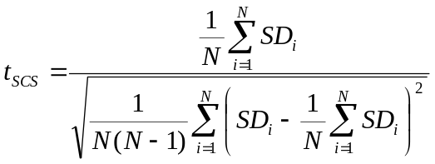 (3)

where SD_{i} is the standardized difference in the actual and estimated return for the ith stock, calculated by dividing the post-ban difference in returns for the ith stock on day T by the standard deviation of the difference in returns in the pre-ban period. Boehmer et al. (1991) demonstrate that the SCS test statistic is not affected by event-induced variance changes. The suitability of the test is contingent on the on the source of the volatility change. As discussed previously, some of the volatility change can be attributed to the ban event. However, given that high volatility continues to be observed in the post-ban period, other factors are clearly influential in the volatility transformation.
The two hypotheses compared are:

H_{o}: CD_{i} = 0 for all i (no correction)
H_{a}: CD_{i} = -BD_{i} for all i (full correction)

where CD_{i} is the mean cumulative difference between actual and estimated returns for stock i from the end of the ban period to day T after the ban and BD_{i} is the mean cumulative difference between actual and estimated returns for stock i during the ban period. Under the null hypothesis, the cumulative difference between actual and estimated returns follows a random walk during the post ban period, culminating in a value not statistically unique to zero. Under the alternative hypothesis, the cumulative difference follows a negative trend in the post-ban period, ultimately correcting the inflation impounded in stock prices during the ban.
Panel A of Figure 8 displays the value-weighted, mean cumulative difference between actual and estimated returns in the post-ban period. The results of the two significance tests of the mean cumulatives are reported in Panel B. At the start of the analysis in Panel A, the mean cumulative difference is set to the cumulative difference realized during the ban period (10.6%); thus, a value of 0% would reflect a full reversal of the inflation realized during the ban. During the three trading days following the ban, inflation rapidly decreases from 10.6% to 3.4%, suggesting a rapid post-ban correction, only to quickly rise back to 10.7% in the following days. In the 20 subsequent trading days, inflation gradually decreases, realizing a point of full reversal in the second week of December, 2009. Focusing on Panel B, it can be observed that the results are similar for both tests. The t-statistic of both tests remains in excess of 2.0 until December 17 or 18, 2009 (depending on the test) suggesting the null hypothesis cannot be rejected with 95% confidence (correction of ban inflation has occurred) until 49 trading days after the ban. It would be expected that any reversal in ban period inflation would occur rapidly once the ban is lifted or at least in a period similar to the inflation accumulation period. It is possible that the high return volatility in the post-ban period masks a more rapid correction, but the extended timeframe of the apparent correction gives us pause. Given the high level of market activity and information flow related to the banned stocks in the post-ban period, a correction noted 49 trading days after the ban would need to be viewed as tenuous evidence of a reversal at best.
[Insert Figure 8 approximately here]

To examine post-ban returns in more detail we sort the banned stock sub-sample by pre-ban performance. When the SEC selected stocks for inclusion in the ban, the foundation of the list was financial sector SIC codes, with no consideration of stock performance. While on average financial sector stocks realized negative returns prior to the ban, negative performance was not pervasive. Only stocks with highly negative returns before the ban would be at risk of liquidity death spirals and be likely candidates for price manipulation by short-sellers. It is also these stocks for which negative information or investor sentiment would most likely be excluded from the market during the short-sale ban, contributing to transitory price inflation. It is not clear what effect, if any, the short-sale ban would have on stocks experiencing relatively positive investor sentiment. To examine the differential effect of the short-sale ban on negatively and positively performing stocks we utilize two additional weighting factors. The negative performance weighting factor is equal to the absolute six month return prior to the ban, with the weighting factor set to zero for stocks which realized a positive return in that period. The positive performance factor is calculated in the same way but the weighting factor is set to zero for stocks which realized a negative return in the six months prior to the ban.

[Insert Figure 9 approximately here]

Panel A of Figure 9 displays the performance-weighted mean cumulative difference between estimated and actual returns for the banned sub-sample in the post-ban period. Panel B and C report the results of the t-test and SCS test of the cumulative means in the same manner as described in Panel B of Figure 8. At the start of the analysis in Panel A, the mean cumulative difference is set to the cumulative difference realized during the ban period (10.0% for both weighting methods); thus, a value of 0% would reflect a full reversal of inflation realized during the ban. Focusing first on Panel B, for stocks which realized more negative returns in the six month prior to the ban, the null hypothesis can be rejected with 95% confidence (suggesting full correction) 8 or 16 days following the ban based on the SCS or t-test results, respectively. With the exception of 2 days, the t-test statistic remains between 2.0 and -2.0 for the entire remainder of the post-ban period. Results are similar for the SCS test statistic. However, during the month of November, the test statistic drops slightly below -2.0 on several occasions and stays below -2.0 in December suggesting the null hypothesis cannot be rejected two months following the ban. As previously discussed, given the blended source of the volatility change coincidental with the ban, the true value of the test statistic likely lies somewhere between the two extremes of the t-test and SCS test statistics. Collectively, the reversal evidence for stocks with negative pre-ban performance can be interpreted to suggest the ban contributed to the temporary exclusion of negative value opinions from the market. Following the ban, the temporary optimism bias impounded in prices was corrected once investors were able to trade on negative value opinions via short-sales.
In contrast to the negative performing stocks, positive performing stocks sustained the inflation realized during the ban to (at least) the end of the post-ban period (Panel A, Figure 9). This result is supported by t-test and SCS test statistics for the mean cumulative difference in returns for the positive performance-weighted index which remain well above 2.0 for the duration of the post-ban period (Panel C). Although the magnitude of the estimated inflation during the ban was similar for positive and negative performing stocks, evidence of a post-ban correction in prices is limited for positive performing stocks. As positive performing stocks were not likely subject to high liquidity risk or short-seller manipulation, the short-sale ban either contributed to higher than estimated stock prices via other more permanent mechanism(s) or the inflation was potentially caused by a coincidental event. For example, investor sentiment may have been buoyed by SEC intervention in the market after a noteworthy absence of intervention by the Fed in the bankruptcy of Lehman Brothers immediately prior to the ban. Isolating the mechanism or contributing event is difficult, if not ultimately impossible, and correspondingly the inflation noted by our model for positive performing stocks cannot be inequitably related to the short-sale ban.
To obtain an estimate of the dollar cost of the inflation to buyers during the ban period, for each banned stock on each day during the ban, we compute the product of our estimate of the percentage inflation in that stock multiplied by the dollar value of volume in that stock. Summing this measure over all banned securities gives a total dollar value of inflation of $4.9 billion. If only the sub-sample of stocks with negative pre-ban performance is considered, for which reversal evidence is more conclusive, the total dollar value of inflation is estimated to be $2.3 billion. As discussed above, this measure is likely biased downwards by the price effects of speculators who traded to speculate on differences in the valuations of the banned and not-banned stocks. Regardless of whether the full banned stock sample or just the negative performance stocks are considered, this wealth transfer is of sufficient size that it should concern public policy makers at the SEC and elsewhere.

VI. Conclusion

The analyses in this paper indicate that the short-sale ban imposed by the SEC on financial stocks in September 2008 inflated prices relative to where they likely would have traded without the ban. Although speculating on counterfactuals is always difficult, we believe that our factor-analytic model provides a reasonable lower bound on the degree of price inflation that occurred. Our model estimates common daily valuation factors using the sample of stocks that were not banned and uses this information to estimate returns for the banned stocks.
The ability to confidently identify trading effects in a one-shot event study in the midst of so much volatility is quite challenging. We believe that we have substantially improved our inferences through the use of our factor model, but the results are not definitive. In particular, if during the ban period, factors that we did not model affected the banned stocks but not the other stocks, the inflation we identify could be due to those factors. Foremost among such factors would be concerns about the then pending TARP legislation. Our results, however, suggest that it was not a significant factor. Assuming that the price effects that we document are indeed due to the ban, we estimate that buyers paid $4.9 billion more for the banned stocks than they otherwise would have. Based on our analysis of post-ban reversals it is arguable whether the inflation we note for stocks with positive performance prior to the ban can be attributed to the short-sale ban and not coincidental, confounding events. Focusing only on stocks with negative pre-ban performance, for which we find more conclusive evidence of a post-ban reversal of inflation, the total dollar value of inflation is estimated to be $2.3 billion. Such transfers should greatly concern policymakers.
The SEC is charged with maintaining fair and orderly markets. As desirable as high prices may be to most people, the creation of a bias toward long-sellers is inconsistent with fair markets. The results in this study suggest that an unintended consequence of the ban on short trading may very likely have been the loss of substantial wealth by uninformed traders.
The U.K., South Korea, Italy, Indonesia, and six other countries also imposed similar short-sale bans. Although we have not analyzed their experiences, we suspect that similar results to ours would be found. Accordingly, our results should interest regulators throughout the world.

References

Amihud, Y. 2002. Illiquidity and stock returns: cross-section and time-series effects, Journal of Financial Markets 5. 31-56.

Asquith, P., Pathak, P.A. and Ritter, J.R. 2005. Short interest, institutional ownership and stock returns. Journal of Financial Economics 78. 243-276.

Boehmer, E., Jones, C.M. and Zhang, X. 2008. Shackling short-sellers: The 2008 shorting ban, Cornell University, Columbia University and Texas A&M University Working Paper.

Boehmer, E., Poulsen, A. and Musumeci, J. 1991. Event study methodology under conditions of event-induced variance. Journal of Financial Economics 30. 253-272.

Boulton, T.J., Braga-Alves, M.V. 2008. The skinny on the 2008 Naked short-sale restrictions. Miami University and Marquette University Working paper.

Bris, A., Goetzmann, W.N., Zhu, N. 2007. Efficiency and the bear: short-sales and markets around the world. Journal of Finance 62. 1029-1079.

Carhart, M. 1997. On persistence in mutual fund performance. Journal of Finance 52. 57-82.

Charoenrook, A., Daouk, H., 2005. The world price of short selling. Cornell University Working paper.

Chen, J., Hong, H. and Stein, J.C. 2002. Breadth of ownership and stock returns, Journal of Financial Economics 66. 171-205.

Daniel, K. and Titman, S. 1997. Evidence on the characteristics of cross sectional variation in stock returns. Journal of Finance 52. 1-33.

Diamond, W.D. and Verrecchia, D.E. 1987. Constraints on short-selling and asset price adjustment to private information. Journal of Financial Economics 18. 277-311.

Fama, E. and French, K. 1993. Common risk factors of expected stock returns. Journal of Finance 47. 427-465.

Fama, E.F., French, K.R., 1993. Common risk factors in the returns of stocks and bonds. Journal of Financial Economics 33. 3-56.

Lamont, O.A., 2004, Go down fighting: short-sellers vs. firms, NBER Working Paper 10659

Miller, E.M. 1977. Risk, uncertainty, and divergence of opinion. Journal of Finance 32. 1151-1168.

Nagel, S. 2005. Short-sales, institutional investors and the cross-section of stock returns. Journal of Financial Economics 78. 277-309.

Phillips, B. 2009. Options, Short-sale constraints and market efficiency: a new perspective. University of Alberta Working Paper.

Table I

Factor-Analytic Model Return Estimate Accuracy Measures

Table I reports three measures of the predictive accuracy of the factor-analytic model for the banned subset of stocks in the pre-ban period, September 18, 2007 to September 18, 2008 (one year before the short-sale ban) and the post ban period, October 9, 2008 to December 31, 2008. The first measure is the correlation coefficient between actual and estimated value-weighted index returns. The estimated value-weighted returns are computed from the estimates of daily cross-sectional models that decompose the returns of the not-banned stocks into common factors. The second measure is the t-statistic for the paired t-test of the equality of the daily mean returns. The third measure is the correlation coefficient between the factor returns estimated in our cross-sectional model (Equation 2) and the actual values of those factors. Only the return factors appear in this table because only their actual values are known. Results are presented for four model specifications. The three return factor models include only the excess market (ExMkt), the TARP (TARP), and the banned stock (Ban) index returns. BAN is the value-weighted index return to the banned stocks on day t. TARP is the index return to the banned stocks weighted by TARP funds received in 2008 as a fraction common stock market capitalization. The six return factor models include in addition the Fama-French size (SMB) and value (HML) factors as well as the Carhart momentum factor (MOM). The models with three stock characteristics also include inverse price, turnover calculated as the sum of trading volume over the last ten trading days divided by shares outstanding, and volatility calculated as the square root of mean squared returns over the last ten trading days.

Panel A

Model | Correlation coefficient, daily actual value-weighted banned index returns with the corresponding estimated index return |  | Paired t-test  t-statistic, for equality of means
Period | Pre | Post | Pre | Post
3 Return Factor Model | 0.9274 | 0.9340 | 0.37 | 0.47
3 Return Factor Model  with 3 Stock Characteristic Factors | 0.9306 | 0.9335 | 0.08 | 0.09
6 Return Factor Model | 0.9824 | 0.9640 | 0.19 | 0.06
6 Return Factor Model  with 3 Stock Characteristic Factors | 0.9829 | 0.9606 | 0.37 | 0.32

Panel B

Model | Correlation coefficients, actual return factors with estimated return factors
 | ExMkt | HML | SMB | MOM | BAN | TARP
Pre Period (N=254)
3 Return Factor Model | 0.9716 |  |  |  | 0.9255 | 0.9075
3 Return Factor Model with 3 Stock Characteristic Factors | 0.9738 |  |  |  | 0.9247 | 0.9038
6 Return Factor Model | 0.9789 | 0.9164 | 0.9013 | 0.9519 | 0.9773 | 0.9688
6 Return Factor Model with 3 Stock Characteristic Factors | 0.9819 | 0.9171 | 0.8859 | 0.9502 | 0.9778 | 0.9664
Post Period (N=58)
3 Return Factor Model | 0.8970 |  |  |  | 0.8434 | 0.7542
3 Return Factor Model with 3 Stock Characteristic Factors | 0.8767 |  |  |  | 0.8190 | 0.6948
6 Return Factor Model | 0.9272 | 0.6314 | 0.8717 | 0.4903 | 0.9139 | 0.8522
6 Return Factor Model with 3 Stock Characteristic Factors | 0.9167 | 0.6560 | 0.8571 | 0.4360 | 0.9041 | 0.8219

Table II

Inflation Determinants

Table II summarizes regression estimates that characterize the cross-sectional relation between inflation during the short-sale ban (measured in percent) and indicators of whether a stock was on the short-sale ban list, whether it was optioned, and whether the issuer received TARP funding in 2008. For each stock we measure inflation as the difference between the cumulative return estimated from the factor model and the actual cumulative return. Models 1 and 2 are estimated with the full stock sample, while Model 3 is estimated only with the banned stock sample. BAN, OPTION and TARP are 1,0 indicators of whether the stock was included on the short-sale ban list, it had listed options, and the issuer received TARP funding before December 31, 2008. The control variables are SIZE, market capitalization on October 8, 2008; SHORT, the percentage of float sold short on September 15, 2008; AMIHUD, the mean Amihud measure of illiquidity (Amihud, 2002); VOLAT, the mean squared return. The latter two means are measured over the year before the short-sale ban. The table reports standardized coefficient estimates with t-statistic values in parentheses below. Coefficient values statistically significant at conventional levels (α=0.05) appear in bold face.

 | Dependent Variable = Inflation
Variable | Model 1  (N=4810) | Model 2  (N=4810) | Model 3  (N=676)
INTERCEPT | 0 | 0 | 0
 | (1.80) | (2.11) | (4.69)
BAN | 0.12 | 0.14
 | (7.77) | (5.52)
OPTION | -0.019 | 0.009 | -0.14
 | (1.30) | (0.54) | (3.38)
TARP | 0.013 | 0.010 | 0.030
 | (0.84) | (0.67) | (0.80)
SIZE | 0.062 | 0.067 | 0.040
 | (4.29) | (4.19) | (1.03)
SHORT | -0.023 | -0.026 | -0.088
 | (1.56) | (1.75) | (2.00)
AMIHUD | 0.019 | 0.022 | 0.00
 | (1.32) | (1.18) | (0.00)
VOLAT | 0.084 | 0.053 | 0.25
 | (5.76) | (3.28) | (6.15)
OPTION*BAN |  | -0.10
 |  | (4.53)
SIZE*BAN |  | -0.006
 |  | (0.38)
AMIHUD*BAN |  | -0.012
 |  | (0.61)
VOLAT*BAN |  | 0.098
 |  | (4.56)
R² | 0.03 | 0.04 | 0.06

Figure 1

Cumulative Index Returns

This figure reports cumulative index returns to NYSE, AMEX and NASDAQ stocks sorted by inclusion on the SEC short-sale ban list between September 19th and October 8th, 2008. Panel A plots value-weighted cumulative index returns for the banned and not-banned subsamples. This panel also plots cumulative banned stock index returns weighted by short interest on September 15th, 2008 and by TARP funds received in 2008 as a fraction of market capitalization on October 28, 2008. Panel B plots value-weighted cumulative index returns for banned stocks that received and did not receive TARP funds in 2008. We calculated all returns as dividend- and split-adjusted log price relatives. The short-sale ban period is shaded.

Panel A
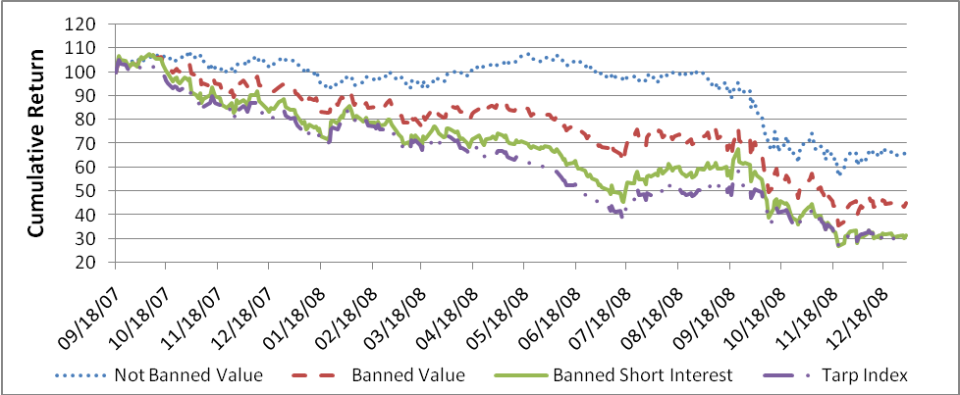

Panel B
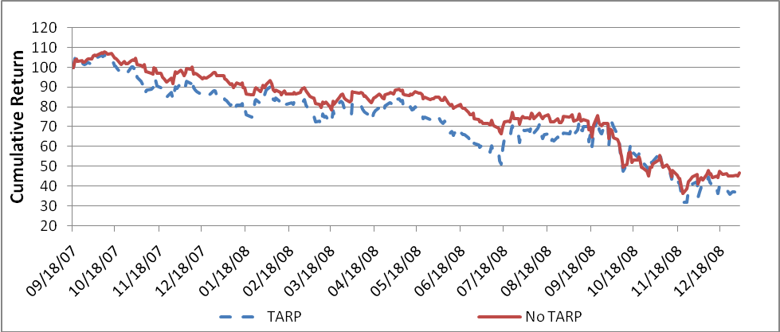

Figure 2

Mean Short Interest

This figure plots mean short interest for non-banned and banned stocks between January 15th and December 31st, 2008, where short interest is defined as the percentage of float sold short and not repurchased. Means are value weighed in Panel A and short interest weighted in Panel B, where the short interest weight is the percentage of float sold short. Stocks with missing float data in the Short Squeeze database are excluded.

Panel A: Value-weighted means

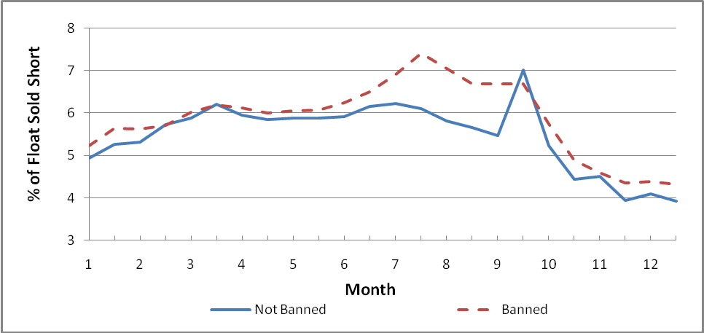

Panel B: Short-interest weighted means

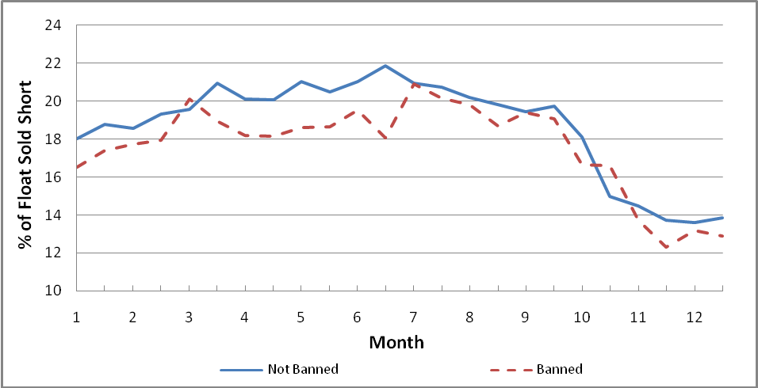
Figure 3

Actual and Estimated Cumulative Banned Index Returns in the Pre-Ban Period

This figure plots value-weighted cumulative indices of actual returns and corresponding returns estimated from the factor analytic model, in the pre-ban period, for the banned stock sub-sample. Estimated returns are computed using the six return factor model with three stock characteristic factors presented in Equation 2.

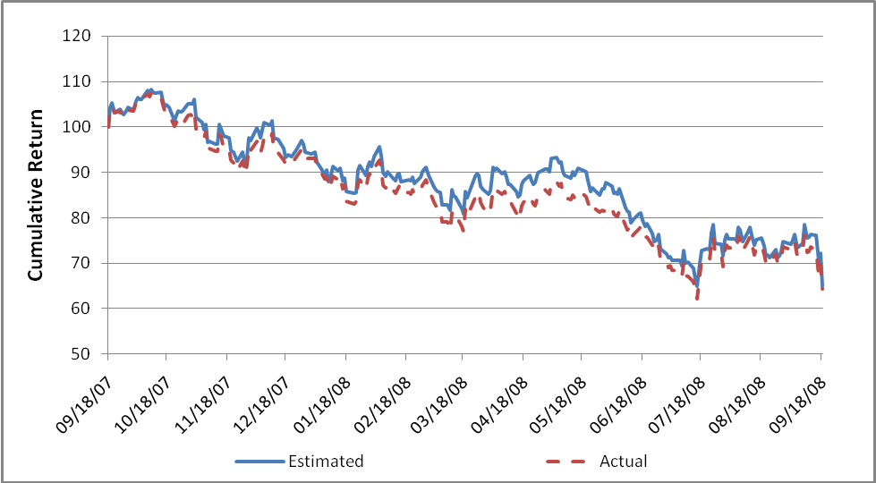
Figure 4

Value-Weighted Cumulative Returns for the Banned Sub-Sample Surrounding the Ban Period

This figure plots value-weighted cumulative indices of actual returns and corresponding returns estimated from the factor analytic model, for the banned stock sub-sample over a period starting 14 trading before the 14-day SEC short-sale ban and ending 14 days after the end of the ban. The period of the ban is shaded.

Panel A
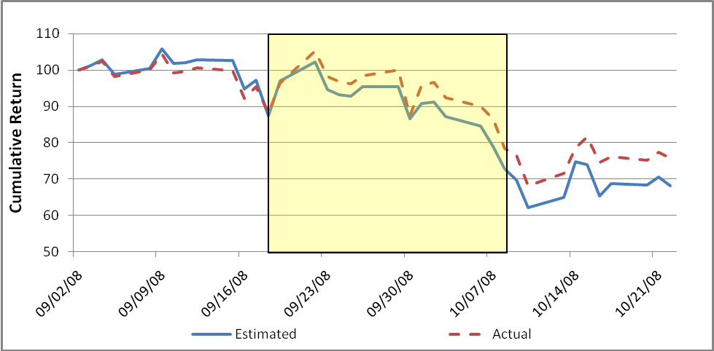

Panel B

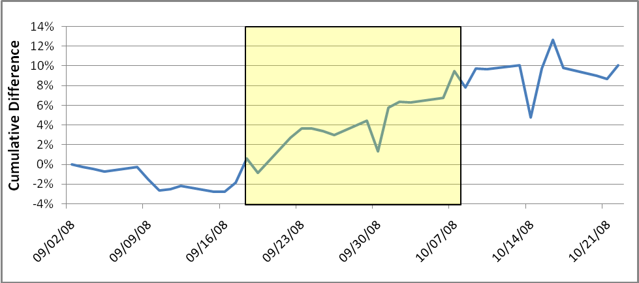

Figure 5

Short Interest-Weighted Banned Stock Return Indices in the Ban Period

This figure plots short interest-weighted cumulative indices of actual returns and corresponding returns estimated from the factor analytic model, for the banned stock sub-sample over a period starting 14 trading before the 14-day SEC short-sale ban and ending 14 days after the end of the ban. The period of the ban is shaded.

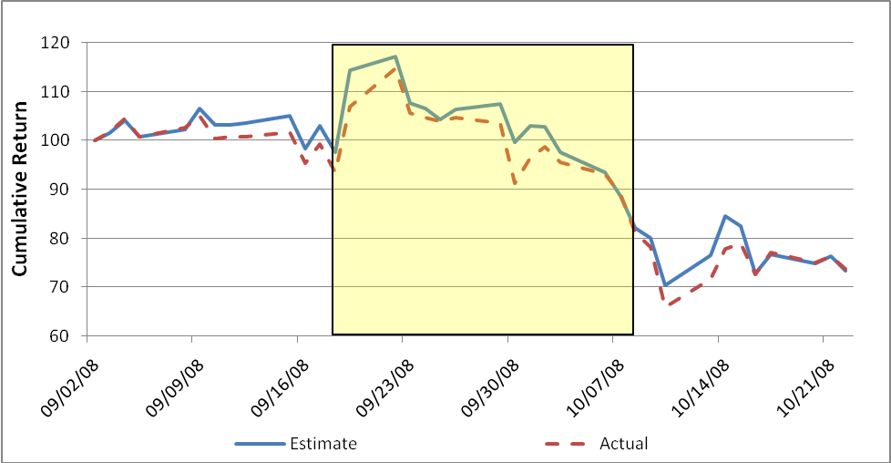

Figure 6

Difference between Actual and Estimated Short Interest-Weighted Banned Stock Return Indices, for Stocks with and without Listed Options

This figure plots the difference between short interest-weighted indices of actual returns and corresponding returns estimated from the factor analytic model, for the banned stocks, classified by whether options could be traded on the stocks, over a period starting 14 days before the 14-day SEC short-sale ban and ending 14 days after the end of the ban. The period of the ban is shaded.

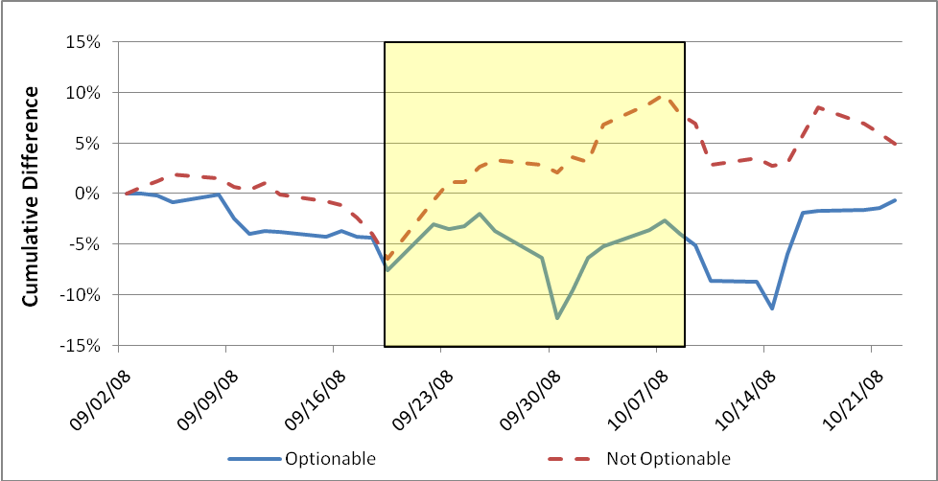

Figure 7

Rolling Volatility

This figure plots rolling volatility of the banned value and the banned short interest-weighted indexes over the sample period. The weighting factors are market capitalization and the percentage of float sold short on September 15, 2009 for the value and short interest-weighted indexes, respectively. Rolling volatility is calculated as the square root of the mean squared return of each index over the prior 14 trading days. The period of the short-sale ban is shaded.

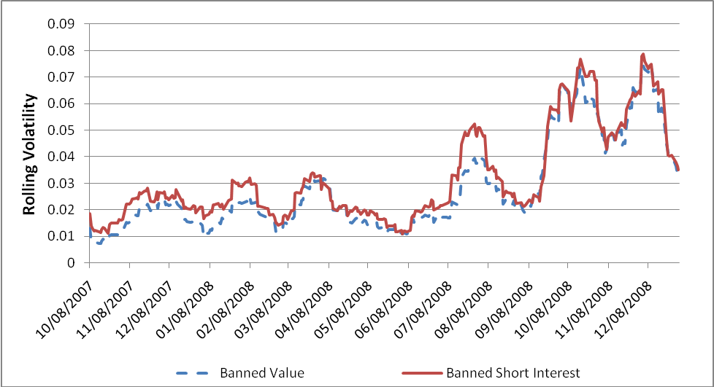
Figure 8

Combined Sample Post-Ban Period Analysis

Panel A of this figure plots the value-weighted, mean cumulative difference between actual and estimated returns for the banned stock sub-sample from the end of the short-sale ban to the end of 2008. At the start of the analysis the cumulative difference is set equal to the cumulative difference between actual and estimated returns accrued during the ban period.

Panel B reports test statistics testing the two hypotheses:

H_{o}: CD_{i} = 0 for all i (no correction)
H_{a}: CD_{i} = -BD_{i} for all i (full correction)

where CD_{i} is the cumulative difference between actual and estimated returns for stock i from the end of the ban period to day T after the ban and BD_{i} is the cumulative difference between actual and estimated returns for stock i during the ban period. T-test and standardized cross-sectional (Boehmer et al., 1991) test statistics are reported. The conventional t-Test statistic significance threshold values of 2.0 and -2.0 are referenced by dotted lines.

Panel A

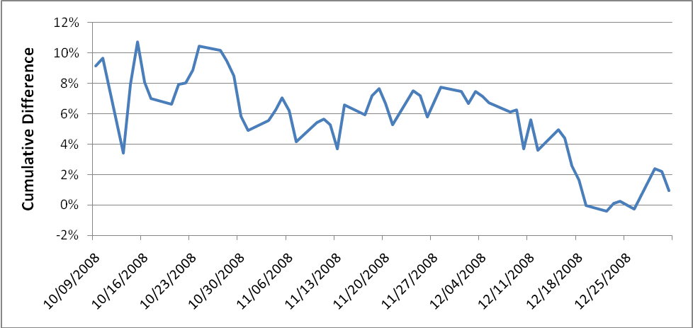

Panel B

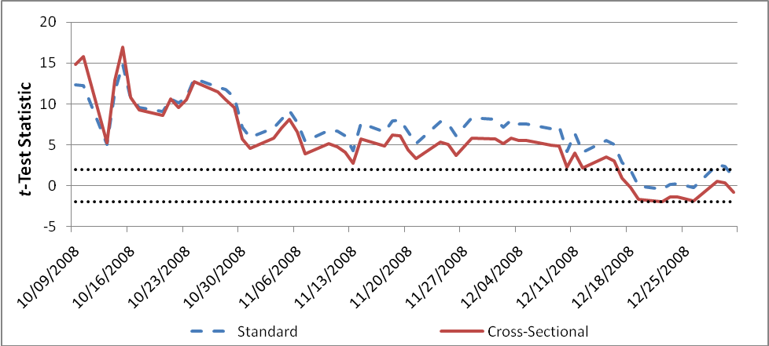

Figure 9

Positive vs. Negative Performance Sub-sample Post-Ban Period Analysis

Panel A of this figure plots the mean cumulative difference between performance-weighted indices of actual and estimated returns for the banned stock sub-sample from the end of the short-sale ban to the end of 2008. The indices are weighted by absolute six month stock return prior to the ban. For the negative performance weighting, the weighting factor is set to zero for all stocks with a positive six month return prior to the ban. Correspondingly, for the positive performance weighting factor, the weighting factor is set to zero for all stocks with a negative six month return prior to the ban.

Panel B reports test statistics testing the two hypotheses:

H_{o}: CD_{i} = 0 for all i (no correction)
H_{a}: CD_{i} = -BD_{i} for all i (full correction)

where CD_{i} is the cumulative difference between actual and estimated returns for stock i for the negative performance-weighted index from the end of the ban period to day T after the ban and BD_{i} is the cumulative difference between actual and estimated returns for stock i during the ban period. T-test and standardized cross-sectional (Boehmer et al., 1991) test statistics are reported. The conventional t-Test statistic significance threshold values of 2.0 and -2.0 are referenced by dotted lines.

Panel C reports the same tests as Panel B but for the positive performance-weighted index.

Panel A

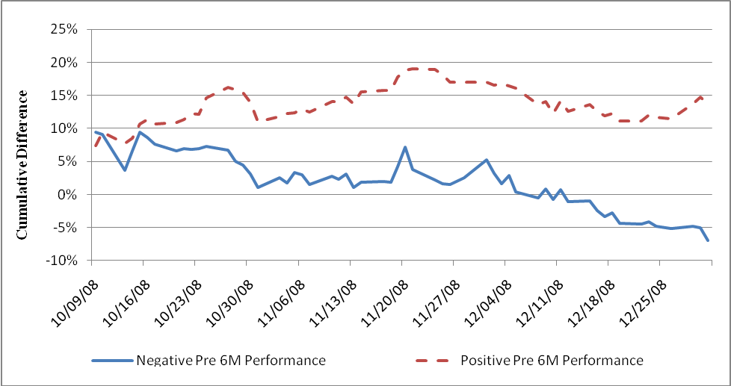

Panel B

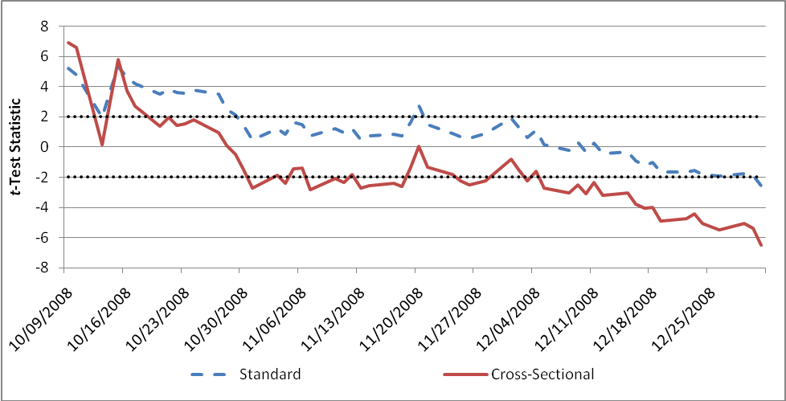

Panel C

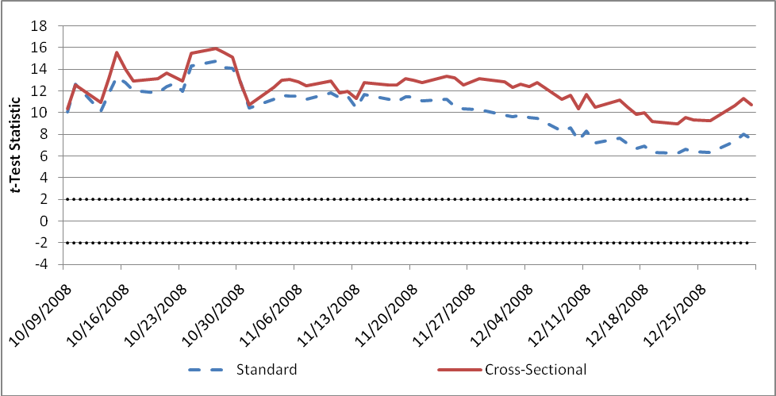

 Harris is at the Marshall School of Business, University of Southern California, Namvar is at the Paul Merage School of Business, University of California, Irvine, and Phillips is at the University of Waterloo, School of Accounting and Finance. A portion of this work was completed while Phillips was at the University of Alberta, School of Business. All correspondence should be sent to: Ethan Namvar email: enamvar@uci.edu tel.: 949-824-4622 fax.: 949-824-8469 mail: Paul Merage School of Business, University of California, Irvine, Irvine, CA, 92697-3125
In SEC Release No. 34-58592, the Acting Secretary, Florence E. Harmon cites an earlier SEC release dated July 15, 2008 (related to the ban on naked short-selling) which states that: “We intend these and similar actions to provide powerful disincentives to those who might otherwise engage in illegal market manipulation through the dissemination of false rumors and thereby over time to diminish the effect of these activities on our markets.”
On October 2, 2008, the SEC announced that the ban would end three days after the TARP bill was passed. The bill was passed on October 3 and revised on October 14. The short-sale ban ended on October 8.
See for example Chen et al. (2002), Lamont (2004), Nagel (2005) and Asquith et al. (2005).
On Friday, September 19, 2008 the SEC banned short-sale transactions for banks, insurance companies and securities firms identified by SIC codes 6000, 3020-22, 6025, 6030, 6035-36, 6111, 6140, 6144, 6200, 6210-11, 6231, 6282, 6305, 6310-11, 6320-21, 6324, 6330-31, 6350-51, 6360-61, 6712 and 6719. The September 19, 2008 ban list included 848 firms. Many firms filed complaints asking to be included on the list. The SEC subsequently added 149 more firms to the list between September 22 and October 7, 2008. Ten firms initially included on the list requested removal. Our classification of banned stocks includes all stocks added to the ban list between September 19 and September 26, 2008. We exclude stocks added after September 26 and stocks removed from the list after initial inclusion.
For robustness we replicate our analysis using stock data from the DataStream database and find the same results.
Such securities were primarily ETFs for which we suspect information about shares outstanding was often inaccurate.
We use daily market capitalization to compute the value-weighted indices.
We use the percentage of float sold short on September 15, 2008 to compute the short interest-weighted indices. Float data was not available for 735 of the stocks in our 4810 stock sample. For stocks missing float, we used shares outstanding instead.
We obtained daily Fama-French and momentum factor data from Kenneth French’s website.
We computed the TARP banned stock index by weighting each banned stock by the fraction of October 28, 2008 common stock capitalization represented by all TARP funds received between October 28, 2008 and December 31, 2008. The weights for banned stocks that did not receive TARP funds are zero.
See Daniel and Titman (1997) for a similar application of this modeling methodology.
Our sample concludes at the end of 2008 due to data availability limitations in the CRSP database. As previously commented, for robustness we also replicate the model over a longer timeframe utilizing stock data from DataStream and find similar results.
We cannot conduct a similar analysis for the cross-sectional stock characteristic factors because their actual values are unknown.
For simplicity the six factor model with stock characteristics is referred to as the factor-analytic model in the remainder of the paper.
Further support of the significance of the inflation for the banned sub sample is provided in the multivariate regression analysis discussed below.
Optionable stocks include stocks listed on the NYSE/AMEX, Chicago Board or the Philadelphia Options Exchanges at the time of the ban.
Variation in the magnitude of inflation between optionable and non-optionable stocks is noted only for the short interest-weighted and multivariate regression models. For the value-weighted results, no appreciable difference was found in the magnitude of inflation for optionable and non-optionable stocks (9.5% and 10.1%, respectively, relative to the aggregate sample result of 10.6%). This result is not unexpected. Within the banned sub-sample, optionable stocks are on average over twice the size (market capitalization) of non-optionable stocks. Thus, utilizing a value weighting method to calculate mean inflation biases against finding a difference in inflation between optionable and non-optionable stocks. For this reason the short interest weighted method and multivariate analysis give a more reliable assessment of the difference in inflation between optionable and non-optionable stocks and we focus upon these methods for this analysis.
We measure illiquidity using the Amihud Illiquidity Ratio (Amihud, 2002) calculated as the daily ratio of absolute stock return to the dollar value of trading volume.
Note that we are unable to include the interaction of TARP and BAN as all TARP stocks were also banned, thus the interaction variable is not full rank with inclusion of the TARP base variable.
The short-sale ban sub-sample is approximately evenly split between positive and negative performers. Of the 676 stocks in the sub-sample, 315 stocks realized negative returns in the six months prior to the ban.
For robustness we replicate the models using the performance weighted ban index returns in place of the value weighted ban index in the factor analytic model and find the same result.
We obtained the individual stock inflation estimates from the value-weighted cross-sectional regression results.
The SEC provides the following mission statement on its website (www.sec.gov): “The mission of the U.S. Securities and Exchange Commission is to protect investors, maintain fair, orderly, and efficient markets, and facilitate capital formation.”

