The Financial Impact of Knockoffs on the Original Fashion Design

Gil Appel
Glazer Faculty of Business and Management, Ben-Gurion University of the Negev
appelg@post.bgu.ac.il
Barak Libai
Arison School of Business, Interdisciplinary Center, Herzliya
libai@idc.ac.il
Eitan Muller
Arison School of Business, Interdisciplinary Center, Herzliya
Stern School of Business, New York University
emuller@stern.nyu.edu

June 2016

The authors would like to thank On Amir, Michael Haenlein, Liraz Lasry, Irit Nitzan, the participants of the Marketing Science and EMAC conferences and the participants of the seminars of the business schools at University of California at Davis, the University of California at San Diego, and Stanford University, for a number of helpful comments and suggestions.

The Financial Impact of Knockoffs on the Original Fashion Design

Abstract

Whether to legally protect original fashion designs against knockoffs is an ongoing debate among US legislators, industry groups, and legal academic circles, with a disagreement even on the fundamental question of whether the effect of a knockoff on the profits of an original design is positive or negative. Yet to-date this discussion has not utilized marketing knowledge and formal approaches, which are very relevant to questions raised. We combine data collected on the growth of fashion items with industry statistics, to create the first formal analysis of the essential questions in the base of the public debate. Our results highlight the negative role of ubiquity of the design, which can affect the original design demand due to consumers’ quest for uniqueness, and show how it can have an extensive impact on original design profitability. We explore the contribution of the opposing forces that constitute the knockoff financial effect on original designs, and discuss the implications of a suggested legal protection period on this effect.

Keywords: design piracy; knockoffs; diffusion of innovations; disadoption; need for uniqueness
Introduction
Consider Figure 1 that depicts several apparel items designed and manufactured by the high-end fashion firm Trovata, alongside nearly identical items produced by the clothing retail chain Forever 21. While Trovata sued Forever 21 for copying these items, the lawsuit was eventually settled out of court (Odell 2009). This may not be surprising, given the failure of numerous lawsuits against Forever 21 and other US firms that have copied fashion designs (Hemphill and Suk 2009). The reason for these failures is that in the US there is no legal protection against design piracy of fashions: a situation in which a firm creates a copy, or “knockoff”, of another firm’s design without its logo, the latter being legally protected.
Because of its possible impact on the US fashion industry, and due to large scale and low cost of copying, design piracy has drawn much attention and lobbying efforts on the part of the US fashion industry. It has become a major issue for public policy makers and the source of an on-going debate in the academic legal literature (Barnett 2005; Cotropia and Gibson 2010; Hemphill and Suk 2009). It has also drawn much attention in the global fashion market, as the use of fast fashion imitation in designs has become a flourishing industry in various countries (West 2011). In the past few years, several separate bills designed to protect US fashion items from design piracy – mainly via a legal protection period such as that instituted in the European Union – were introduced in the US Congress; however, none of them have been successful (see Ellis 2010; Riordan 2013)
Some aspects of the debate on design piracy relate to its industry-level effects, such as the consequences for industry innovativeness and the affordability of fashions to mainstream consumers (Marshall 2013; Raustiala and Sprigman 2006). However, an essential part of the debate, which is our focus here, regards the knockoff’s possible influence on the demand for the original design. Stakeholders in favor of knockoff restrictions cite the damage to original designs caused by substitution, which represents the loss of sales due to consumers who would have purchased the original design, yet instead buy the knockoff (Lamb 2010). Opponents of knockoff restrictions highlight the role of acceleration, which may actually benefit the original, and whereby the presence of a pirated design increases the awareness of the design, and thus can possibly have a positive effect on the growth of the original (Givon, Mahajan, and Muller 1995; Raustiala and Sprigman 2012).
Yet, a critical effect that has received less attention in this debate is the negative consequences for an original design stemming from a larger user base created by a knockoff. This effect, labeled uniqueness, stems from the fact that we use fashion to signal to others, as well as to ourselves, our social status and distinctiveness from others. Recent research strongly supports the idea that for many products, and fashions in particular, uniqueness considerations play a significant role in consumers’ adoption and attrition decisions (Berger and Heath 2007, 2008; Chan, Berger, and van Boven 2012; Cheema and Kaikati 2010), and in turn in aggregate market demand (Amaldoss and Jain 2005; Bakshi, Hosanagar, and Van den Bulte 2013; Berger and Le Mens 2009; Joshi, Reibstein, and Zhang 2009).
We investigate the overall effect of a knockoff on the original item, and in particular the following two questions which are fundamental to the public debate on knockoffs:
1) When a knockoff follows an original design, would the overall effect on the profitability of the original be positive (due to acceleration), or negative (due to substitution and uniqueness), and what is the relative contribution of each factor?
2) To what extent would a legal protection period that would delay the launch of a knockoff, as proposed by several US lawmakers, change the situation?
Much of the discussion of the above issues has been based on anecdotes and conceptual arguments with no structured, data-based analysis of the issue. We contribute to this debate by presenting a new fashion growth model calibrated with market data, and using it to examine the combined knockoff effects of acceleration, uniqueness, and substitution on the net present value (NPV) of the original. We were aided by market data on prices and knockoffs, and in particular, by large US retailer that enabled us to follow the growth of fashion items to calibrate the range of our model parameters. We then examine via simulations how design piracy would affect the NPV of an original item, looking separately at two different product classes identified in the data: handbags, and apparel. Among our major results are the following:
- The overall knockoff effect. We find that when the acceleration, substitution and uniqueness effects are taken into account, there is largely an overall negative effect of a knockoff entry on the revenues from an original item. Yet, the effect can considerably vary among product classes. Based on the range of parameters we use, the negative knockoff effect is stronger for handbags, where the price difference between the original and knockoffs is particularly large. It is smaller, yet still largely negative, in the case of the apparel items we examined. Our findings suggest that original fashion items that diffuse rapidly, and whose consumers care more about their use by others, are damaged more by the introduction of a knockoff.
- The role of the opposing forces. While uniqueness emerged as having, on average, a stronger negative effect on the original’s NPV than the positive effect of acceleration, the difference between the two was not necessarily very large. However, the negative effect of uniqueness is considerably larger than that of substitution. This is of particular interest given that industry groups focus on the direct damage that can be caused due to substitution, and to date have less cited the indirect – yet as we see here possibly substantial harm – caused by design ubiquity.
- The role of time lag prior to knockoff entry. Given the calls to protect original US fashion items via a legal protection period, similar to the case in the EU, we analyze the effect of a protection period’s duration on the original product’s NPV. We find that a short protection period may have little effect, or may even harm the original, due to the dynamics of the opposing forces of uniqueness and acceleration. For longer protection periods, a positive effect is observed, and it grows in an almost linear pattern as the protection period lengthens.
The rest of the paper is organized as follows: Following the section on the three main elements of design piracy, we develop a fashion diffusion model that will serve as the basis for our analysis. We calibrate the model parameters using empirical data, and subsequently using simulations, we explore the effect of a knockoff’s entry on the profitability of the original design. We conclude with a discussion on the implications of our results. In Figure 2 we plot the analysis process that follows.

Acceleration, Substitution and Uniqueness
The matter of design piracy is part of a larger issue of the extent of legal protection that should be extended to original items. The debate on legal protection for fashion designs in the US has been conducted mostly in the legal literature, alongside several unsuccessful efforts to pass a law thereon in the US Congress (see Marshall 2013 for a recent review). However, as most of the work in the legal literature is verbally argued, there is little empirical work that directly aims to weigh the costs and benefits of design piracy and assess its overall monetary impact. Three major factors can be considered in this regard:
Acceleration
Opponents of legal intervention sometimes argue that original design owners can actually benefit from design piracy, as market availability of many non-original products can trigger contagion processes that drive adoption of a design, potentially accelerating adoption among users who choose the original (Raustiala 2012). It has further been argued that these effects should be especially crucial in fashion items, where conformity is important for the creation of a trend (Cotropia and Gibson 2010). These arguments are consistent with models of diffusion of innovation, where it has been traditionally assumed that the existence of additional adopters (captured in the parameter of internal influence) could help accelerate the growth of the relevant products (Van den Bulte and Stremersch 2004). The positive effect of previous users is attributed to social influence via word of mouth, which helps reduce risk and uncertainty, signaling an accepted norm that others would want to follow; and to a growing functional utility in the case of products with network externalities (Peres, Muller, and Mahajan 2010).
These dynamics can create a positive spillover effect of brand competition, which can help to accelerate the growth of a new brand if the social influence among consumers is occurring also at the category level (Krishnan, Seetharaman, and Vakratsas 2012; Libai, Muller, and Peres 2009). In the same manner, competition from software piracy can help accelerate the original, and new product vendors may want to forgo exclusivity to enjoy the benefits of a larger customer base (Prasad and Mahajan 2003). Thus, similarly, the knockoff can help the growth rate of the original design.

Substitution
Some knockoff buyers would have purchased the original design if a knockoff had not been available, thereby creating a negative monetary effect on the original design (Lamb 2010). While fashion designers see this issue as a real threat to their sales, it has been questioned, as many knockoffs are sold for a much lower price, and thus target a market that would not have purchased the original anyhow (Raustiala and Sprigman 2006). The issue may depend on the manufacturers’ abilities to create knockoffs that are similar in terms of look and quality. Recent reports suggest that knockoffs are becoming considerably similar to original items, to the extent that they confuse even sophisticated shoppers, especially when sold online (Holmes 2011, Wilson 2007).

Uniqueness
The idea that adoption by other users constitutes a considerable part of the utility of a fashion good goes back more than a century (Simmel 1904; Veblen 1899). This interdependency holds, since fashion helps people signal identity and status, and helps signal the group with which they identify as distinguishable from others.
This effect is increasingly associated with consumers’ need for uniqueness, manifested in the drive to differentiate oneself from others through the acquisition, utilization, and disposition of consumer goods, which serve to develop and enhance one’s self-image and social image (Tian, Bearden, and Hunter 2001). The need for uniqueness is recognized as a major driver of consumer behavior in the context of fashions as well as other markets (Berger and Heath 2007; Chan, Berger, and Van Boven 2012; Timmor and Katz-Navon 2008). Recent studies have further investigated the role of uniqueness in increasing the desirability of certain goods (Berger and Shiv 2011), moderating consumers’ word-of-mouth levels in publicly consumed goods (Cheema and Kaikati 2010), and affecting consumers’ preferences on brand visibility (Han, Nunes, and Drèze 2010). Some research in this area have considered this issue from the lens of the tensions between specific groups of customers: For example, looking at fashion markets that consist of two segments, where the followers segment tries to imitate the leaders, while the leaders do not want to be associated with the followers (Simmel 1904; Joshi, Reibstein, and Zhang 2009; Amaldoss and Jain 2005).
It is thus clear that fashion items that become too popular might very well lose their uniqueness (Berger and Le Mens 2009). Indeed while considered less than substitution in the public debate knockoffs , it has been recognized by some legal researchers that the ubiquity of knockoffs can damage sales of the original item, due to the loss of use by others (Hemphill and Suk 2009; Raustiala and Sprigman 2012). Yoganarasimhan (2012) demonstrated how these dynamics drive some fashion firms to restrict information on the ubiquity of the brand, while other firms make it highly available. Yet no effort was made to quantify the magnitude of the effect.
Overall, the picture of fashion markets is ambiguous on the overall effect of a knockoff: On one hand, the size of the user base may drive acceleration of new fashion growth due to increasing social influence. On the other hand, the size of the user base may have a negative effect, in that it creates deceleration due to the negative effect of design ubiquity, as described above. In addition, substitution may take demand from the original design. The total effect, however, has not been formally assessed to date, and it is not clear what may be the dominant force. We next provide the framework that will enable us to separate the monetary consequences of the three main effects of design piracy discussed above.
Growth of Fashions in the Presence of Design Piracy
To examine the questions raised above, we move in three stages: First, we present a new product growth model that takes into account the conflicting effects of acceleration and uniqueness, and use it to assess their respective effects on the net present value (NPV) of the revenues of an original item that encounters a knockoff. Second, we gather empirical data to calibrate the model’s parameter range. We then use this parameter range to run simulations that will help us to study the effect of a knockoff on an individual original item. The model is based on the following assumptions:
Time of the introduction of the knockoff: We assume that the knockoff is introduced at the same time as the original. This is consistent with market reports indicating that knockoffs are often introduced into the market at the same time as or very shortly after original products (Tan 2010; Wilson 2007). We later examine the case of knockoffs that are introduced with a time lag.
Perception of uniqueness: A fundamental issue relates to how original item buyers and potential buyers are affected by others’ use. Here we assume that they are affected both by the number of original items and by the number of knockoffs that they see in the market. While the former is obvious, an explanation is on point for the latter.
Note first that the owner, who paid for the good, is likely of course to be aware of the source of that good, as they could closely inspect it, and conclude its originality from the point of purchase, and from the price. Yet, this is much harder when one needs to assess the originality of an item another individual uses. Often the interaction between the parties is brief, and sometimes from a distance (e.g., walking down the street); and the ability to inspect the item closely, and even more so to know where it was purchased and for how much, may be low. This is especially true as pirated items become ever more similar to originals, and consumers often find it hard to distinguish between originals and knockoffs (Gentry, Putrevu, and Shultz 2006; Holmes 2011).
However, even if some original item buyers identify the pirated design as coming from another manufacturer, it is not evident that this can help much in terms of loss of uniqueness. Popular culture uses terms such as “same dress disaster” to describe occurrences to which it is claimed that “every woman can relate” (Newbold 2012). In such situations, the issue is the design’s ubiquity, while the lookalike items’ source does not necessarily mitigate the harm. In fact, even if the original item’s owner identifies the source and cares about it, it is not necessarily reasonable for her to assume that others can discern it as well.
Therefore, we assume that consumers are affected in their quest for uniqueness by a user base, which includes both the original design and its knockoff. In the section on robustness checks we relax the assumption and consider the case that some of the original item adopters are not affected by knockoffs. As we will show, even when this share of original users is substantial, the fundamental results we get are largely robust.
Sales of the knockoff: While our interest is the NPV of the original product, we model both the growth of the original and the knockoff while their market potentials differ (which can be attributed to a price difference, as we elaborate soon). We assume that the adopters of the original design may affect the knockoff adopters and vice versa in two contrasting ways: On one hand, the inter-market interactions will increase the positive social influence through the number of perceived users, thus accelerating adoption. On the other hand, this reciprocal effect will cause more current and potential adopters of the original product to cross their uniqueness thresholds, thereby increasing attrition.

The model
Three populations to follow: Consider Figure 3 and define the following three groups of interest for the original design as well as the knockoff: Users - those who adopted the fashion item and still use it; Disadopters - those who adopted, yet stopped using, wearing, or displaying the item due to extensive adoption by others; and Avoiders - those who have not yet adopted, and will not adopt the design due to extensive adoption by others. Formally, at each point in time t we consider the following three groups for the design broken down to the original item (i = 1) and the knockoff (i = 2):
x_{it} – the total number of current users
y_{it} – the cumulative number of disadopters
z_{it} – the cumulative number of avoiders
The total number of adopters is the sum of current users (x_{it}) and disadopters (y_{it}). The available market potential at each point t is the portion of the market that has not yet adopted, has disadopted, or has avoided the fashion.
The market equations: The total market potential for the design (original and knockoff) is M. If α is the share of potential knockoff adopters in M, M_{1t} is the market potential for the original at time period t and M_{2t} for the knockoff (Equations 1 and 2 respectively). To include the substitution effect, we define the percentage of the knockoff potential market that would have purchased the original if knockoffs had not been available as β. Thus, the larger β, the smaller the actual market potential the original firm faces. We multiply this factor by the number of people that have already adopted the knockoff (x_{2t} + y_{2t}) to adjust the adjusted market potential for the original at time period t.
(1)
(2)
Note that there can be a difference between the substitution factor β, and the eventual effect of substitution on NPV. The former represents the potential loss due to substitution, or the percentage of the market potential the original potentially loses to those who instead buy the knockoff. The latter is largely based on β, yet takes into account also the consequences of the uniqueness and acceleration effects (e.g., some of the lost potential adopters may not have adopted anyhow due to uniqueness effect). Therefore, the substitution parameter and the total substitution effect will not necessarily be the same.
Modeling the individual threshold: The negative effect of others is modeled via a uniqueness threshold approach, where each individual has a personal threshold for the number of product users he or she is willing to tolerate before avoiding or disadopting the product. In the context of product use, threshold models have largely been used to model adoption dynamics (Granovetter 1978; Valente 1995), but can be also used to describe attrition processes (Granovetter and Soong 1986). Thus, if the current fraction of adopters is x_{it} / M, and if H is the uniqueness threshold level with a given distribution in the population, then the effective market potential for rejections at time t, i.e., the total number of those in the market segment whose threshold has been surpassed is given by . We divide the number of adopters by M and not by M_{it}, since consumers care about the design as a whole and not of the adoption of an item (original or knockoff). We will later examine the possibility that some consumers do differentiate between the original and its knockoff. Since the markets interact, each consumers observes the sum of adopters (x_{1t} + x_{2t}), the adoptions of the design, when considering attrition.
The collective action literature, where threshold models have been extensively used, has largely assumed thresholds with normal distributions (Macy 1991; Valente 1995; Yin 1998), which are actually two-sided truncated normal, as negative thresholds are assumed to be zero (Granovetter and Soong 1986). We follow this literature and assume that H follows a truncated normal distribution with mean μ and a standard deviation of σ, that is: H~N(μ, σ²). Notice that the individual threshold is fixed and not a function of the number of adopters, while this is not an innocuous assumption, it is the prevalent assumption in thresholds (Granovetter and Soong 1986; Macy 1991; Valente 1995).
Changes in the number of consumers who passed their threshold: We follow the change in number of rejections (the change in both disadopters and avoiders) by estimating the change in consumers who passed their threshold yet did not reject.
To calculate this number at time t, we need to take all consumers whose uniqueness threshold (M_{it} multiplied by the probability to pass the threshold) has been passed, and subtract from this number all consumers who have already disadopted or avoided the fashion, i.e., y_{it} and z_{it} to arrive at the following equation:
(3)
Separating disadopters and avoiders: Equation 3 gives us the change in overall rejections, but since we wish to evaluate the change in each population separately, we need to find a way to split the two. For this reason, we examine the distribution of the threshold between the current user population and the potential consumer population. Since the individual threshold is independent of the adoption probability, the adoption process acts like a process of sampling from a population with a conditional uniqueness threshold distribution. Thus, the proportion of users whose uniqueness threshold has been passed, and the proportion of individuals in the remaining market potential whose uniqueness threshold has been passed, will converge to the same mean; with standard deviations depending on the sizes of the two populations. The equation itself appears in Appendix A.
Calculating the change in current users: The final part needed for the model is to find the change in the number of users (x_{it}). Following the diffusion modeling paradigm, we look at adoption as a growth process with diffusion parameters p (representing external influence such as advertising) and q (internal influence such as word of mouth) and long-range market potential (Peres, Muller, and Mahajan 2010). However, in each time period t, the current remaining market potential is the share of the market that did not adopt or avoids the item. The adoption pattern captures the change in the number of users and the change in the number of disadopters in each time period t and to separate the two, we need to subtract the change in disadoptions from the number of new adoptions:
(4)
Hence, word-of-mouth communication is assumed to take place between adopters (captured in x_{it}) and consumers who have not yet adopted, have disadopted, or have avoided the fashion within each market segment. Note that when μ = 1 and σ = 0, no one abandons the fashion, and the model reduces to the classic Bass diffusion model.
Our interest here is not only in the total effect, but also in its breakdown into the three factors described above, i.e., acceleration, substitution, and uniqueness. Therefore, we examine additional scenarios that enable us to isolate the respective effect of each source on the NPV of the original product – see Appendix A for the process of decomposing the total effect into isolated components. We also computed an interaction effect of the three main effects, yet found it to be small with a median (and mean) of less than 1%. Since it does not affect the substantive results we describe next, we highlight the results for the three main effects and the total effect.
Calibrating Model Parameters with Fashion Data
Our next task is to empirically estimate the model so as to justify the range of parameter values used in the simulation. Towards this end, we use two sources of information: Fashion growth data on original designs, online data on price difference between originals and knockoffs, and industry statistics on the extent of knockoffs.
Fashion sales data over time are not readily available to researchers, and so there is a dearth of quantitative academic research looking at fashion growth. We were able to follow the growth of a number of original fashion items by scraping the transaction data from a large US retailer. In the first stage, we aimed to find original fashion items that face a knockoff. Online search helped us to identify fashion blogs dedicated to matching original designs and their knockoff counterparts (see Web appendix A for a discussion of the process we went through in this respect). We gathered the names and price levels of 300 pairs of original-knockoff design items.
In the second stage, we could now look for sales data for these design items using the data from the large US retailer, one of the largest traders in the U.S. with yearly transactions worth tens of billions of dollars, and are considered fairly representative of the population of online buyers in general. Indeed, recent internal research at this retailer demonstrated a high correlation between the trend of sales of new brands compared to the US market as a whole. In particular, designer clothing and fashions in general, are among the retailers’ most prominent categories, and it draws major fashion brands to sell directly through its “fashion outlet”.
Using the data from the retailer, we could construct the growth of some of the items in our list. This demanded very large-scale data analysis efforts, going through hundreds of millions of transactions, to identify the relevant brands we were looking for as parts of the transactions. We restricted the cases we were looking for as follows:
- We looked only for the monthly transactions of the new originals over time. The reason we did not look for knockoffs, is that knockoffs may appear under differing listing titles and as part of the collection (e.g., of chains such as Forever 21), and not necessarily in a design-identifiable form on the retailers site. Thus, while one can expect originals to be frequently sold on a regular basis, much cheaper knockoffs may not be as ubiquitous. We have indeed examined this issue based on the listing titles we collected, and saw that knockoff sales trend identification is not practical.
- We looked only for original items that had a minimum substantive sales data (see Web Appendix A for details). Note that we looked for specific items, and thus getting continuous sales data over time in sufficient numbers was not straightforward. In particular, we looked for items that had at least 4 years (48 months) of continuous data points, sales having already reached a first peak, with at least 100 items sold overall.
- After this selection process, we were left with temporal sales data on 20 fashion items out of our initial list – 11 clothing items, 2 footwear items, and 7 handbags – whose data we used to calibrate the model parameters (see the first column of Table 1).

The magnitude of the price difference
The items we gathered represent a wide range of prices, and in particular, price differences between the original and the knockoff. For each individual fashion item in our list, we define the price markup ratio as the price of the original divided by the price of the knockoff. We observed two classes of items: handbags, with an average price markup ratio of 40.5; and apparel (clothing and footwear), which had a price markup ratio of about 5 on average (5.1 for footwear, and 5.03 for clothing). This is reflected also in differences in the absolute prices of the originals we examined: $2,191 for handbags, and $224 for apparel. We incorporated the price markup ratio into our modeling approach by looking at the differential effects between apparel and handbags in two ways:
First, the price difference between the original and the knockoff can help determine the extent of substitution, following the framework in Staake and Fleisch (2008). The idea is that the larger the price difference between the original and the knockoff, the less the cheaper knockoff can serve as a substitute for the more costly original. Based on experimental research, Staake and Fleisch (2008, p. 130) suggested that the substitution factor can be expressed as the inverse of the price markup factor. In the case of the products we studied, this means an average substitution factor β = .025 for handbags (i.e., 2.5% of the handbag knockoff’s potential buyers would have purchased the original had a knockoff not been available); and β = .198 for apparel.
Second, we used the price markup ratio to assess the market share of potential knockoff buyers α. We were aided by industry data under which the US sales of pirated designs are estimated to account for 5% of monetary sales of the US fashion market (Wilson 2007). Given this, we can calculate the unit share of pirated design for a given item with a price markup ratio level using this simple conversion: Knockoff Market share = (5%*price markup ratio) / (95% + 5%*price markup ratio).
Given the price markup ratio, we can assess the average knockoff share of handbags at 68%, and 21% for apparel. This means that of every 100 fashion handbags sold, 68 are knockoffs; and for 100 apparels item sold, 21 are knockoffs. Note, however, that α (the share of potential knockoff adopters in M) is not equal to the pirated design unit share. We needed to estimate the value of parameter α such that, when simulating, our model will result in an average of 68% of the adoptions coming from the pirated design segment for handbags, and 21% for apparel. Thus parameter α could be thought of as the initial estimate of the knockoff share. Thus, we need to estimate the knockoff share iteratively when estimating the model’s other four parameters. This iterative procedure led to an estimation of α to be .76 for handbags, and .26 for apparel, which leads to final shares of 68% and 21%, as required by the price markup factors.
Given the large differences in prices as reflected in the price markup ratio measure between these product classes and the consequent implications for model parameters, we decided to conduct the analysis separately on these two categories: handbags, and apparel.

Parameters for the fashion items
In order to develop the ranges for the simulated model, we estimated the parameters of the fashion growth model for the examined items, using Equations 1-4 and A2. We used NLS (Srinivasan and Mason 1986) to estimate the adoption equation (Equation 4). Note that using these equations we could express Equation 4 just as a function of x, y, and z, and therefore the variables y and z were treated as latent variables whose changes over time follow Equations 3 and A2. We used the two average values of α and β as the input (one for apparel, and one for handbags).
To illustrate out procedure, we use the following example: One of the fashion designs we examined is Primp’s Anchor hoodie together with the low cost virtual copy by Forever 21. To estimate the parameters of the design we used nonlinear least-squares estimation (NLS), with a grid of 2,500 starting points so as to prevent algorithm convergence into local minima, selecting the parameter set that minimize the sum of square error (SSQ). As this fashion design belongs to the apparel class, we set the external parameters, α = .26 and β = .198. In Figure 4, we demonstrate the fit of the model to the adoption pattern of this particular hoodie (R² = 84.4%). The estimated model parameters for each fashion item are given in Table 1.

Full model simulation
Following the analysis for the fashion items, we use the parameter range of Table 2 to explore the monetary consequences of the introduction of a knockoff. The ranges were taken separately for each of the two product groups. To obtain a range of values of α and β parameters, we draw for members of each group a random value in the range of the group mean, plus or minus 20% (i.e., if handbag average α is .76, the range would be between .61 and .91). We took a random draw of 10,000 parameter sets for each product group, and compared the NPV obtained at the end of the growth horizon.
The time horizon used for the simulation was 132 months (periods), the maximum number of periods in our dataset. In the simulated growth parameters, we used the variability of the distribution (σ/μ) rather than the standard deviation (σ), as varying μ and σ orthogonally does not take into consideration their correlation, nor the relative effect of σ on μ (Snedecor and Cochran, 1989). Due to the possible nonlinear effects of the diffusion and threshold parameters on the NPV ratio, we used a lognormal configuration when drawing the patterns (Goldenberg et al. 2007). Since the external influence parameter (p) is significantly correlated with μ in our sample (for both handbags and apparel, with correlations of .893 and .761 respectively), we controlled for that in our pattern draws (the correlations between all the other parameters were not significant). To translate the temporal adoptions into NPV, we assumed an annual discount rate of 10%, and assumed one unit of revenue for each item upon adoption.

Results: Knockoffs’ Effects on NPV
Table 3 presents the results of the three main effects – substitution, acceleration, and uniqueness – as well their combined effect on the NPV of the original in percentage of change. We report both median and mean, as the distributions of all effects are considerably skewed. We discuss here the results in terms of the median, yet similar results can be observed by looking at the mean instead of median, though the size effects differ.
Looking at the median effect on the NPV, the smallest effect is the negative impact of substitution, followed by the positive effect of acceleration, and the strongest effect is the negative effect of uniqueness. The overall effect we observe is negative. On average across the two groups, the knockoff creates a 15.2% negative effect on the original’s NPV. Though the results are consistent across the two groups, we do see a considerable difference in the effect size across groups. For handbags, we see that the knockoff effect is stronger, with a total effect of -29.1%, compared to -9.4% for apparel. In the case of handbags, the acceleration effect is higher than that of apparel, yet the uniqueness effect jumps from -26.9% for apparel to -53.9% for handbags, thus driving the overall effect.
Note that while the median (and average) total effect is negative, it is not negative in all cases, with an extent that differs across groups. 4.6% of handbags actually benefit from the knockoff according to our calculations, and the percentage increases to 25.4% for the apparel group. Certainly, we cannot say categorically that a knockoff always creates a negative effect.

Result 1a. Taking into account acceleration, substitution, and uniqueness, the expected overall effect (median and average) of the introduction of a knockoff is a reduction in the NPV of the original item. Yet the extent of this reduction can considerably vary across product groups.

Result 1b: Among the three effects – acceleration, substitution, and uniqueness – the effect of uniqueness on the NPV of the original (a negative effect) is the strongest on average, followed by acceleration (a positive effect), and then a small negative substitution effect.

Are the dynamics consistent across product types?
We have observed that the total effect of a knockoff differs between handbags and apparel. The next question we ask is if this difference manifests in terms of the size effect only, or if the fundamental dynamics differ between the two groups. We tested the effects of the model parameters on the main drivers of the total effect, i.e., acceleration and uniqueness. These are the dependent variables in the linear regressions whose results are presented in Table 4. The independent variables represent three types of effects: the speed of diffusion (internal influence q and external influence p); the uniqueness threshold parameters (mean μ and variability σ/μ); and the parameters that represent the extent of the knockoff phenomenon (share of potential knockoff adopters α and the substitution factor β). Note that the total effect of a knockoff is the effect on the NPV of the original, and so a negative coefficient sign indicates greater damage.
We see first that there is a difference in the parameter values between the product classes. Using a two-sample Hotelling’s t² test, we see that the difference between the set of coefficients is significant (a t-test between each pair of coefficients was also significant). Yet across the three regressions, the signs are similar between classes, as the fundamental effects appear consistent.
Second, we observe that the faster the diffusion of the item (larger values of p and q) the smaller the acceleration effect of the knockoff: The knockoff naturally helps less original items that diffuse rapidly on their own. This is also the direction of influence on the total effect, and so faster-growing products with shorter life cycles are damaged more by knockoffs, i.e., they suffer from the uniqueness effect, yet do not enjoy the acceleration.
Third, a higher mean of the uniqueness threshold brings about lower knockoff damage, as a higher threshold implies that the average user needs more others who adopt the very same fashion item in order for him or her to disadopt. Thus, higher threshold indicates that users care less about others’ adoption, and consequently the damage from the specific knockoff is lower.
Another intriguing finding is that the effect of variability in uniqueness is positive, i.e., that distributions with larger variance lead to a smaller uniqueness effect. This result is driven by the truncation of the threshold’s distribution: When we increase the variability in a threshold with truncated tails, the share of consumers with zero threshold levels increases, as these consumers are highly sensitive to uniqueness and if they are not the only ones with the design, they will never adopt. The loss in NPV associated with these consumers is not attributed to knockoffs, as they will disadopt even if there are no knockoffs in the market (see Scenario A, Appendix A). However, the smaller loss to NPV from consumers that now have higher thresholds can be attributed to knockoffs, since they will ultimately disadopt if there are too many other fashion items in the market (original or knockoffs). To control for this effect, we examined what happens if we remove from the regression all of the parameter sets with truncated thresholds (when two standard deviations from the mean were lower than zero or larger than one), and the effect became significantly negative (-.534 for handbags, and -.065 for apparel), as expected.
The last issue is that there is a small or non-significant effect of the knockoff extent parameters (α and β) on the total effect in both groups. Because the two parameters are driven in our model by the original / knockoff price difference, one might wonder if this result implies a smaller effect of such a difference. We argue that this is not the case, as price should affect all parameters in the model. Exclusive, higher-priced items may grow at a different pace than do lower-priced items, and consumers may be sensitive in a different way to others’ adoptions. We indeed see a sizeable difference in the knockoff effect, the parameter values for the speed of diffusion, and the uniqueness threshold parameters, across both groups: handbags, and apparel.

The Effect of a Time Lag in the Introduction of the Knockoff
Unlike the US, the European Union has some limited legal protection for fashion designs. The European Community Design Protection Regulation (DPR), which went into effect in 2002, extends fashion designs a legal protection period of three years, which can be extended for registered designs. Fashion industry advocates in the US have lobbied for similar protection: For example, the Innovative Design Protection and Piracy Prevention Act (IDPPPA), introduced to the US Senate in 2010, was intended to provide legal protection to the US fashion industry consistent with the system currently in place in the EU (Hackett 2012).
What would be the impact of a legal protection period on the overall monetary effect of a knockoff? To examine this issue, we re-ran the above simulations using the same ranges of parameter values, this time looking at cases in which the knockoff enters the market later than the original product. We ran 59 sets of simulations, and for each successive set added one month to the time lag between the introduction of the original and the introduction of the knockoff, such that the maximum time lag was 60 months.
When looking at the percent reduction in the NPV of the original product in the presence of a knockoff as a function of the duration of the protection period, the following picture emerges (see also Figure 5): A short protection period does not necessarily help the original: In the first year after launch, the protection period might even cause slight damage to the original product’s NPV (up to 2% in our simulations), as we observe in the case of apparel.
This negative short-term effect occurs because the rate of drop in the acceleration effect with the time lag is faster than that of uniqueness. Thus, early on, the entry of a knockoff may affect the original positively (acceleration) more than negatively (uniqueness). In apparel, where diffusion speed is slow to begin with (lower values of p and q), the damage to acceleration is especially strong, and in fact in the first year, overwhelms that of uniqueness. Yet as the lag time lengthens, the power of uniqueness begins to dominate, and the benefits from acceleration cannot outweigh the damages from the loss of uniqueness.
One may want to use caution in the interpretation of our simulations at this stage, as the parameter estimates we use may not be policy invariant: Changing the legal situation has the potential to change firms’ strategies and market dynamics. Still, we can say based on the current situation, and using the parameter range we examined, that for a time lag of three years, the current duration of legal protection in the EU, knockoff damage to the NPV is certainly reduced, yet most of it still exists (see Figure 5).
Result 2: The effect of a time lag (legally mandated postponement) to the introduction of a knockoff is non-monotonic for short lag, and monotonic for longer lags: A short time lag may not affect the NPV of the original design, and in fact may even damage it. For the ranges we analyzed, the positive effect of the protection period is observed primarily for time lags that are over one year long.

Robustness Checks
Following the above, we conducted a number of robustness checks to test whether the basic results for the overall influence of the three effects of knockoff on the NPV of an original product, and in particular the dominance of uniqueness, hold when changing the basic assumptions of the model.

A case of heterogeneous consumers
Aggregate new-product growth models use the number of adopters as a proxy to the power of social influence in the population. In reality, potential adopters meet and interact only with a small subset of the total population. Yet aggregate-level adoption can serve as a reasonable proxy of the dynamics created, even when taking into account individual-level social network dynamics (Fibich and Gibori 2010). This phenomenon has been shown also for the collective action threshold effect created for network externalities in new product growth (Goldenberg, Libai, and Muller 2010). Consistent therewith, we also used the aggregate level of design adopters to assess the uniqueness effect.
However, if some of members of the original adopter segment identify the knockoffs they see, yet do not care about design ubiquity stemming from this particular knockoff, it may decrease the knockoff effect observed in the market. Note that the impact should be manifested both in the positive effect of acceleration and in the negative effect of uniqueness.
To consider this case, we constructed an extended model that takes into account various consumer types (see Web appendix B). Toward this end, it is convenient to use a typology of consumer types used by Han, Nunes, and Drèze (2010) in the context of brand prominence in the market for luxury goods. One of the advantages of using their terminology is the fact that some data are available on the composition of these groups in the market. Patricians are defined as consumers who buy the original items, can differentiate between knockoffs and originals, and are aware of the actual number of originals in the market. Yet they do not care about, and are not affected by, the number of knockoffs in the market, possibly because they mingle only with other patricians (who only buy the originals). Parvenus, on the other hand, buy the original but do care about the number of pirated designs in the market, for many possible reasons such as not being able to differentiate originals from knockoffs. Poseurs are the consumers that for a number of reasons, mostly economic oriented, buy the knockoff and not the original. Parvenus and Poseurs do not differentiate between knockoffs and originals, treating them as one. Patricians are of course immune to the substitution effect, as they consider only the original as worth buying and will not consider the pirated design as an alternative, thus the share of the market lost to substitution is removed only from the Parvenus.
In the extended model that is fully presented in Web Appendix B, β and α remain the same per class, yet we add a new parameter, γ, for the level of piracy recognition, or the share of original buyers that differentiates between original and pirated designs, i.e., Patricians in the framework of Han, Nunes and Drèze (2010). Following their paper for the sizes of the various segments, we used 19.6% as the share of Patricians from the original buyer population. We then re-ran the extended model and did the full model simulation to explore the change in the results.
The extended model results suggest that indeed the knockoff damage effect is reduced when there is an indifferent portion within the original market potential. Yet the total effect of the knockoff remains negative and substantial for both product groups: The total negative effect on handbags decreased from 29.1% in the original model to 24.8%; and in the case of apparel from 9.4% in the original model to 4.1%.

Other robustness tests
We conducted a number of other robustness checks to further test whether the basic results for the overall influence of the three effects of knockoff on the NPV of an original product, and in particular the dominance of uniqueness, hold when changing the basic assumptions of the model. We examine the sensitivity of the results to changes in the price markup between the original design and the knockoffs (as captured by the α and β parameters); the sensitivity of the results in a homogeneous threshold scenario (setting σ/μ = 0); and when using a uniform rather than normal distribution when modeling the threshold. The results are largely robust with respect to the changes we examined.

Discussion
Calibrating our model with fashion growth data and industry statistics, this study is the first effort to formally assess the effect of a knockoff on the NPV of an individual original design. Our results can contribute to the ongoing public policy discussion on the need to restrict knockoffs. We do not aspire to provide an answer as to what to do in this on-going debate: As we discuss above, there are additional industry level and legal issues, which are beyond our scope here. However, given the central role of the damage to an original design plays in this discussion, our main findings can serve as an important input to this dialog. In particular, these include:
Fashion knockoffs have a largely negative effect. In most cases, the introduction of a knockoff damages the NPV of the individual original. Thus, the positive effect of acceleration is not enough to offset the damage created by the knockoff in other ways. This result is important in light of voices in this debate that dismiss the possible damage of a knockoff, and is consistent with the concerns in the industry regarding the damage of design piracy.
Uniqueness plays an important role that should be acknowledged. Industry observers often refer to substitution, rather than uniqueness, when considering the monetary damage created by knockoffs (Lamb 2010), possibly because the effect of substitution is more vivid and easier to quantify. However, our results suggest that a greater damage is caused by the effect of design ubiquity in the market. We further find that the uniqueness effect exists even when a substantial percentage of the original item market is indifferent to the ubiquity of knockoffs.
The difference between product groups. We find that the knockoff damage effect can considerably differ between product groups. In particular, our analysis was based on two product groups: handbags, where the originals were high-priced and far costlier than the knockoffs; and apparel, where the difference was smaller. We saw that the basic results of the effect on the knockoff’s damage were similar; yet the extent of the phenomenon differed, as the knockoff damage was considerably higher for handbags than it was for apparel.
The time lag effect. The public discussion on the damage of knockoffs is conducted in the presence of a heated debate on the need to restrict knockoffs by mandating a time lag during which knockoffs cannot enter the market, as is the case in the EU. There are many facets to such a law that are not considered here. For example, the ability to enforce such a law and how a knockoff will be defined in this regard. Recall also that we need to be cautious given the possible policy-variant nature of some parameters.
Using our approach, we can still provide the first structured sensitivity analysis in this regard, to study what would be the effect of a time lag for knockoffs. What we see is that a short period (up to about one year in our data) will not be of much help to the original and may even create harm, as early period is when the original enjoys the acceleration, and this is in particular important for products that otherwise diffuse slowly. However, for longer periods we see a monotonic reduction in knockoff effect. Our analysis suggests though that even after a lag of three years, most of the damage to the NPV can still occur.

A broader look at design piracy
The question of knockoff effect is larger than what we are able to discuss here. Other long-term and industry-level issues should be taken into account. For example, we focused on the immediate harm to the specific item, yet the negative effect of a knockoff might be even stronger if the knockoff also causes long-term harm to the brand equity of the original firm. This may occur, for example, in cases where the design is very much associated with the relevant brand, and quality issues or ownership by those not in the target market can affect brand associations. Resultant negative word-of-mouth communications could also be introduced into the framework (Mahajan, Muller and Kerin 1984).
Neither did we consider various market-level effects. For example, one could argue that consumer welfare might go up in some cases, due to ubiquity of a design with a lower price. Nor did we consider consecutive fashion cycles as in Pesendorfer (1995). From yet another angle, there are claims that the presence of knockoffs drives firms to introduce more products into the market, which can promote innovation and thus positively affect the industry and consumers (Raustiala and Sprigman 2012). We do not address the existing controversy on this issue (Cotropia and Gibson 2010; Hemphill and Suk 2009), as industry-level analysis is beyond the scope of this research. What we do argue is that the discussion should include an informed analysis of knockoffs’ effects on individual firms, a topic that is lacking in previous literature, and can benefit from our approach and findings here.

Concluding comment
In their influential work on design piracy, Raustiala and Sprigman (2006) argued that since high-intellectual property (IP) protection has never existed in the US fashion industry, “it is difficult to say with any certainty whether raising IP protections would raise consumer or producer welfare”. While achieving certainty on this issue is certainly difficult if not impossible, given its importance to public policy we believe that it is possible to come much closer. A formal analysis that aims to isolate the effect of each component of the knockoff effect and to provide insight into understanding the total effect is an appropriate means toward achieving this end. We believe that this study is just one step in that direction.
References
Amaldoss, Wilfred and Sanjay Jain (2005), “Conspicuous Consumption and Sophisticated Thinking,” Management Science, 51 (10), 1449-1466.
Bakshi, Nitin, Kartik Hosanagar, and Christophe Van den Bulte (2013), “New Product Diffusion with Social Attraction and Repulsion,” working paper, Wharton School, University of Pennsylvania.
Barnett, Jonathan M. (2005), “Shopping for Gucci on Canal Street: Reflections on Status Consumption, Intellectual Property, and the Incentive Thesis,” Virginia Law Review, 91 (6), 1381-1423.
Berger, Jonah and Chip Heath (2007), “Where Consumers Diverge from Others: Identity Signaling and Product Domains,” Journal of Consumer Research, 34 (2), 121-134.
——— and ——— (2008), “Who Drives Divergence? Identity Signaling, Outgroup Dissimilarity, and the Abandonment of Cultural Tastes,” Journal of Personality and Social Psychology, 95 (3), 593–607.
——— and Gaël Le Mens (2009), “How Adoption Speed Affects the Abandonment of Cultural Tastes,” Proceedings of the National Academy of Sciences U S A, 106 (20), 8146—8150.
——— and Baba Shiv (2011), “Food, Sex and the Hunger for Distinction,” Journal of Consumer Psychology, 21 (4), 464–472.
Chan, Cindy; Jonah Berger, and Leaf Van Boven (2012), “Identifiable Yet Not Identical: Combining Social Identity and Uniqueness Motives in Choice,” Journal of Consumer Research, 39 (3), 561-573.
Cheema, Amar and Andrew M. Kaikati (2010), “The Effect of Need for Uniqueness on Word of Mouth,” Journal of Marketing Research, 47 (3), 553-563.
Cotropia, Christopher A. and James Gibson (2010), “The Upside of Intellectual Property’s Downside,” UCLA Law Review, 57 (4), 921-982.
Ellis, Sara R. (2010), “Copyrighting Couture: An Examination of Fashion Design Protection and Why the DPPA and the IDPPA Are a Step Toward the Solution to Counterfeit Chic,” Tennessee Law Review, 78 (1), 163-211.
Fibich, Gadi and Ro’i Gibori (2010), “Aggregate Diffusion Dynamics in Agent-based Models with a Spatial Structure,” Operations Research, 58 (5), 1450-1468.
Gentry, James W., Sanjay Putrevu, and Clifford J. Shultz, Jr. (2006), “The Effects of Counterfeiting on Consumer Search,” Journal of Consumer Behaviour, 5 (May-June), 245-256.
Givon, Moshe, Vijay Mahajan, and Eitan Muller (1995), “Software Piracy: Estimation of Lost Sales and the Impact on Software Diffusion,” Journal of Marketing, 59 (1), 29–37.
Goldenberg, Jacob, Barak Libai, and Eitan Muller (2010), “The Chilling Effects of Network Externalities,” International Journal of Research in Marketing, 27 (1), 5-14.
——— and Sarit Moldovan (2007), “The NPV of Bad News,” International Journal of Research in Marketing, 24(3), 186-200.
Granovetter, Mark (1978), “Threshold Models of Collective Behavior,” American Journal of Sociology, 83 (6), 1420-1443.
——— and Roland Soong (1986), “Threshold Models of Interpersonal Effects in Consumer Demand,” Journal of Economic Behavior and Organization, 7 (1), 83-99.
Hackett, Petal Jean (2012), “Cutting Too Close? Design Protection and Innovation in Fashion Goods,” CESifo Working Paper Series No. 3716.
Han, Young Jee, Joseph C. Nunes, and Xavier Drèze (2010), “Signaling Status with Luxury Goods: The Role of Brand Prominence,” Journal of Marketing, 74 (4), 15-30.
Hemphill, C. Scott and Jeannie Suk (2009), “The Law, Culture, and Economics of Fashion,” Stanford Law Review, 61 (5), 1147-1200.
Holmes, Elizabeth (2011), “Fashion Fakes Get More Sophisticated,” Wall Street Journal, June 30, 2011.
Joshi, Yogesh V., David J. Reibstein, and Z. John Zhang (2009), “Optimal Entry Timing in Markets with Social Influence,” Management Science, 55 (6), 926-939.
Krishnan, Trichy V., P. B. Seetharaman, and Demetrios Vakratsas (2012), “The Multiple Roles of Interpersonal Communication in New Product Growth,” International Journal of Research in Marketing, 29 (3) 292-305.
Lamb, Rachel (2010), “Countering Counterfeits: How Luxury Brands Are Challenging the Knock-off Culture,” Luxury Daily, July 5, 2012.
Libai, Barak, Eitan Muller, and Renana Peres (2009), “The Role of Within-Brand and Cross-Brand Communications in Competitive Growth,” Journal of Marketing, (73), 19-34.
Macy, Michael W. (1991), “Chains of Cooperation: Threshold Effects in Collective Action,” American Sociological Review, 56 (6), 730-747.
Mahajan, Vijay , Eitan Muller and Roger A. Kerin (1984), “Introduction Strategy for New Products with Positive and Negative Word of Mouth,” Management Science, (30), pp. 1389-1404.
Marshall, Ashley (2013), “Free Fashion,” Intellectual Property Law Review, 17 (1), 123-141.
Newbold, Alice (2012), “How to Avoid a Same-dress Disaster This Party Season, courtesy of Harvey Nichols,” Telegraph, (accessed April 4, 2014), [available at http://fashion.telegraph.co.uk/news-features/TMG9724215/How-to-avoid-a-same-dress-disaster-this-party-season-courtesy-of-Harvey-Nichols.html].
Odell, Amy (2009), “Trovata’s Suit Against Forever 21 Ultimately Has No Effect on Knockoff Regulations,” New York Magazine, (October 13, 2009).
Peres, Renana, Eitan Muller, and Vijay Mahajan (2010), “Innovation Diffusion and New Product Growth Models,” International Journal of Research in Marketing, 27, 91-106.
Pesendorfer, Wolfgang (1995), “Design Innovation and Fashion Cycles,” American Economic Review, 85(4), 771-92.
Prasad, Ashutosh and Vijay Mahajan (2003), “How Many Pirates Should a Software Firm Tolerate? An Analysis of Piracy Protection on the Diffusion of Software,” International Journal of Research in Marketing, 20 (4), 337-353.
Raustiala, Kal and Christopher Sprigman (2006), “The Piracy Paradox: Innovation and Intellectual Property in Fashion Design,” Virginia Law Review, 92 (8), 1687-1777.
— (2012), The Knockoff Economy: How Imitation Sparks Innovation. New York: Oxford University Press.
Riordan, Staci (2013), “Fashion Copyright Bill Dies in Congress,” Fashion Law Blog, (accessed February 17, 2013), [available at http://fashionLaw.foxRothschild.com/2013/01/articles/fashion-law/fashion-copyright-bill-dies-in-congress/].
Simmel, Georg (1904), “Fashion,” International Quarterly, (10), 130-55.
Snedecor, George W., and William G. Cochran (1989), Statistical Methods, 8th (Ed.).Ames, IA: Iowa State University Press.
Srinivasan, V. and Charlotte H. Mason (1986), “Nonlinear Least Squares Estimation of New Product Diffusion Models,” Marketing Science, 5 (2), 169-178.
Staake, Thorsten and Elgar Fleisch (2008), Countering Counterfeit Trade. Heidelberg: Springer Berlin.
Tan, Irene (2010), “Knock It Off, Forever 21! The Fashion Industry’s Battle Against Design Piracy,” Journal of Law and Policy, 18 (2009-2010), 893-924.
Tian, Kelly Tepper, William O. Bearden, and Gary L. Hunter (2001), “Consumers’ Need for Uniqueness: Scale Development and Validation,” Journal of Consumer Research, 28 (1), 50-66.
Timmor, Yaron, and Tal Katz-Navon (2008), “Being the Same and Different: A Model Explaining New Product Adoption,” Journal of Consumer Behaviour, 262 (June), 249-262.
Valente, Thomas W. (1995), Network Models of the Diffusion of Innovations. Cresskill, NJ: Hampton Press.
— and Stefan Stremersch (2004), “Social Contagion and Income Heterogeneity in New Product Diffusion: A Meta-Analytic Test,” Marketing Science, 23 (4), 530-544.
Veblen, Thorstein (1899), The Theory of the Leisure Class: An Economic Study in the Evolution of Institutions. London: Unwin Books.
West, Brittany (2011), “A New Look for the Fashion Industry: Redesigning Copyright Law with the Innovative Design Protection and Piracy Protection Act (IDPPPA),” Journal of Business, Entrepreneurship, & the Law, 5 (1), 57-86.
Wilson, Eric (2007), “Before Models Can Turn Around, Knockoffs Fly,” New York Times, (September 4, 2007).
Yin, Chien-Chung (1998), “Equilibria of Collective Action in Different Distributions of Protest Thresholds,” Public Choice, 97 (4), 535-567.
Yoganarasimhan, Hema (2012), “Cloak or Flaunt? The Fashion Dilemma,” Marketing Science, 31(1), 74-95.

Tables and Figures

Table 1: Estimation results for the fashion items, by class
Fashion item - Handbags | Time  (months) | External  effect (p) | Internal  effect (q) | Threshold mean (µ) | Threshold variability (σ/μ) | RSE | MSE
Chloe Betty | 83 | 0.016983 | 0.023 | 0.2378 | 0.054 | 6.7 | 43
Chloe Paddington | 95 | 0.006769 | 0.165 | 0.2023 | 0.140 | 71.4 | 4829
Fendi Spy | 93 | 0.025052 | 0.118 | 0.8057 | 0.147 | 133.1 | 16755
Hermes Birkin | 132 | 0.000917 | 0.047 | 0.1214 | 0.163 | 21.8 | 459
Luella Gisele | 111 | 0.000911 | 0.269 | 0.1192 | 0.398 | 7.6 | 55
Marc Jacobs Stam | 87 | 0.002427 | 0.103 | 0.0263 | 0.079 | 50.0 | 2355
Yves Saint Laurent Muse | 87 | 0.003513 | 0.014 | 0.1269 | 0.149 | 18.2 | 311
Average | 98 | 0.008082 | 0.105 | 0.2342 | 0.161 | 44.1 | 3544
Fashion item – Apparel | Time  (months) | External  effect (p) | Internal  effect (q) | Threshold mean (µ) | Threshold variability (σ/μ) | RSE | MSE
BCBG Cotton Poplin Dress | 115 | 0.000006 | 0.133 | 0.0937 | 0.470 | 22.8 | 497
Black Halo Ruffle Dress | 63 | 0.002073 | 0.124 | 0.3795 | 0.033 | 5.8 | 30
Christian Louboutin Decollete (shoe) | 84 | 0.000064 | 0.209 | 0.0007 | 5.221 | 8.2 | 64
Citizens of Humanity Jeans | 114 | 0.000195 | 0.118 | 0.0038 | 4.026 | 487.6 | 227331
Current Elliot Love Jeans | 50 | 0.000028 | 0.578 | 0.0003 | 2.183 | 8.0 | 57
Dr. Martens 1460 (shoe) | 132 | 0.000335 | 0.119 | 0.0474 | 0.232 | 82.2 | 6507
DVF Wrap Dress | 132 | 0.000007 | 0.172 | 0.0008 | 7.752 | 114.1 | 12517
Ed Hardy Tee | 93 | 0.000156 | 0.120 | 0.2497 | 0.226 | 262.1 | 65009
J. Crew Eliza Cami | 79 | 0.000166 | 0.212 | 0.0697 | 0.409 | 14.8 | 206
Juicy Couture Terry Hoodie | 130 | 0.000123 | 0.119 | 0.0474 | 0.379 | 116.9 | 13150
Primp Anchor Hoodie | 86 | 0.000911 | 0.338 | 0.0760 | 0.162 | 16.6 | 261
Seven For All Mankind Dojo Denim | 119 | 0.000730 | 0.022 | 0.1688 | 0.100 | 184.9 | 32769
So Low Foldover Pants | 99 | 0.000942 | 0.038 | 0.1185 | 0.023 | 9.3 | 83
Average | 100 | 0.000441 | 0.177 | 0.0966 | 1.632 | 102.6 | 27576

Table 2: Parameter ranges for the simulation process
Fashion item - Handbags | Parameter Range
External effect (p) | 0.000911 - 0.025052
Internal effect (q) | 0.014 - 0.269
Threshold mean (µ) | 0.0263 - 0.8057
Threshold variability (σ/μ) | 0.054 - 0.398
Share of potential knockoff adopters (α) | 0.608 - 0.912
Substitution factor (β) | 0.02 - 0.03
Fashion item – Apparel | Parameter Range
External effect (p) | 0.000006 - 0.002073
Internal effect (q) | 0.022 - 0.578
Threshold mean (µ) | 0.0003 - 0.3795
Threshold variability (σ/μ) | 0.023 - 7.752
Share of potential knockoff adopters (α) | 0.208 - 0.312
Substitution factor (β) | 0.158 - 0.238

Table 3: Simulation results: The sizes of the various forces on the NPV
Overall (Handbags and Apparel) | Median | Kurtosis* | Skewness** | Average | Variance
Substitution | -1.2% | 21.64 | 0.04 | -2.3% | 0.1%
Acceleration | 20.1% | 8.85 | 2.02 | 25.2% | 5.2%
Uniqueness | -33.8% | 2.19 | -1.17 | -40.0% | 6.9%
Total | -15.2% | 5.23 | 1.10 | -16.5% | 4.9%
Handbags | Median | Kurtosis* | Skewness** | Average | Variance
Substitution | -2.6% | 3.44 | -1.72 | -3.8% | 0.1%
Acceleration | 22.2% | 7.96 | 2.25 | 29.1% | 5.7%
Uniqueness | -53.9% | 0.90 | -0.62 | -53.8% | 8.4%
Total | -29.1% | 1.05 | 0.50 | -27.3% | 3.2%
Apparel | Median | Kurtosis* | Skewness** | Average | Variance
Substitution | -0.3% | 51.22 | 2.02 | -0.9% | 0.1%
Acceleration | 18.5% | 10.14 | 1.73 | 21.2% | 4.4%
Uniqueness | -26.9% | 3.23 | 0.07 | -26.2% | 1.7%
Total | -9.4% | 10.07 | 2.04 | -5.6% | 4.2%
* Kurtosis measures how “peaked” the distribution is: Positive values represent a more peaked distribution, while negative values represent a distribution that is less peaked. The normal distribution has zero kurtosis.
** Skewness is a measure of the “tilt” of the distribution: Positive values represent a left tilted distribution with a short left tail and a long right tail, while negative values represent a right tilted distribution with a long left tail and short right tail. The normal distribution has zero skewness.

Table 4: The effects of the model parameters on uniqueness and acceleration
Parameter - Handbags | Total Effect* | Uniqueness Effect | Acceleration Effect
External effect (p) | -.812 | .206 | -.879
Internal effect (q) | -.319 | -.180 | -.011 (N.S.)
Threshold mean (µ) | 1.373 | .625 | .381
Threshold variability (σ/μ) | .094 | .025 | .041
Share of potential knockoff adopters (α) | .021 | -.296 | .442
Substitution factor (β) | -.016 | -.010 (N.S.) | .014 (N.S.)
R² | .701 | .784 | .532
Parameter - Apparel | Total Effect | Uniqueness Effect | Acceleration Effect
External effect (p) | -.330 | .120 | -.393
Internal effect (q) | -.375 | -.026 | -.340
Threshold mean (µ) | .364 | .377 | .159
Threshold variability (σ/μ) | .436 | .170 | .333
Share of potential knockoff adopters (α) | -.016 (N.S.) | -.222 | .128
Substitution factor (β) | -.010 (N.S.) | -.002 (N.S.) | -.007 (N.S.)
R² | .400 | .303 | .328

* All of the coefficients are standardized; non-significant coefficients are marked with (N.S.).

Figure 1: Fashion designs of Trovata (lower row) vs. Forever 21(upper row)

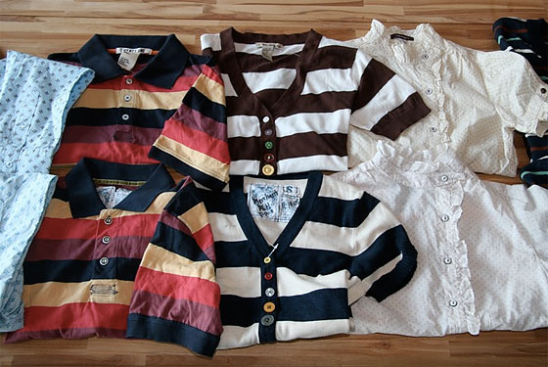

Figure 2: The analysis process’ flow chart

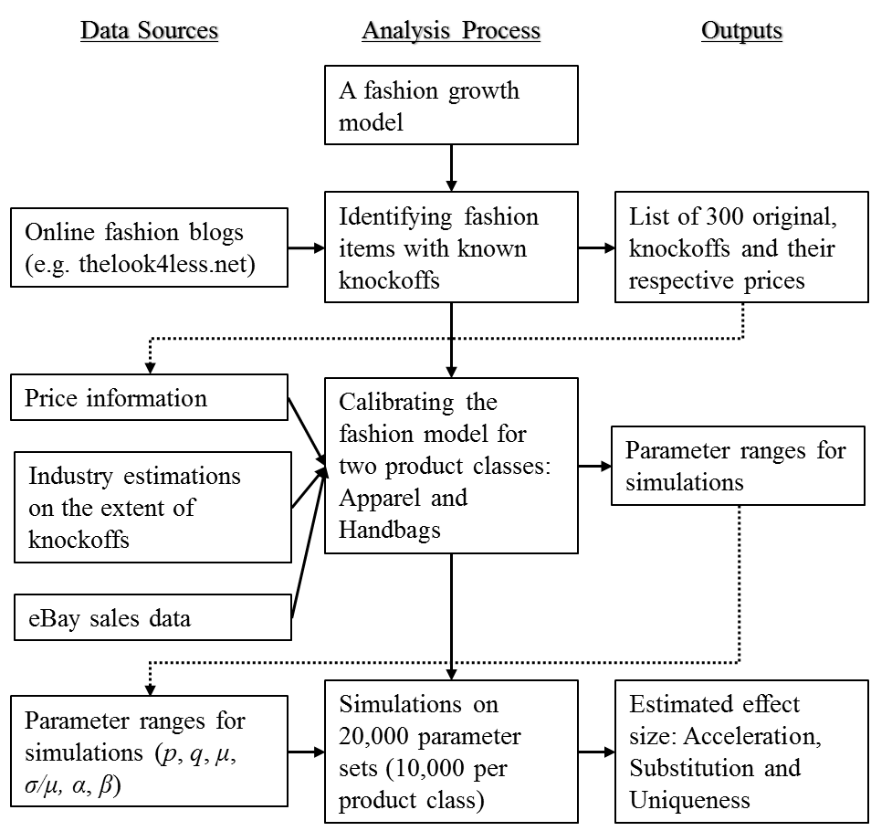

Figure 3: Fashion diffusion framework flow chart
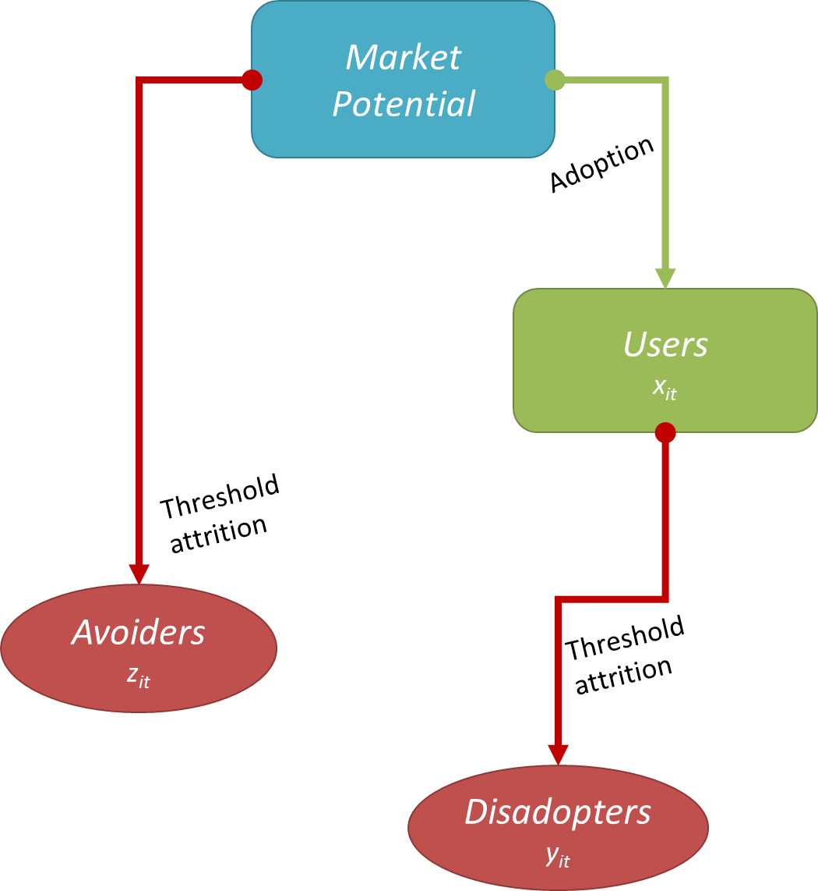
Figure 4: Actual and estimated sales of Primp’s Anchor Hoodie*
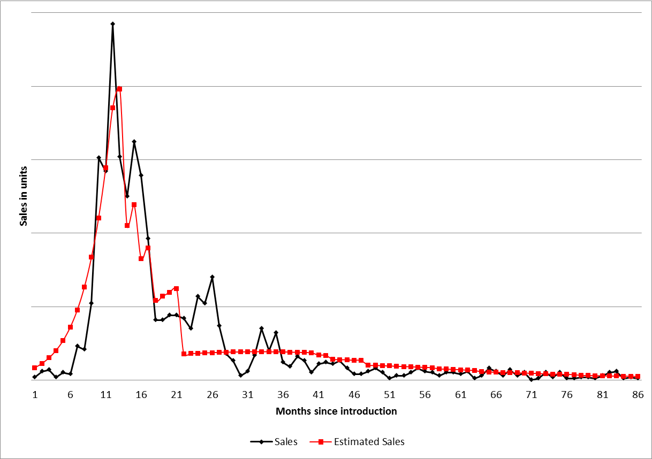
*R-Square = 84.4%. Vertical axis hidden to preserve confidentiality
Figure 5: The impact of design protection period on the profitability of the original
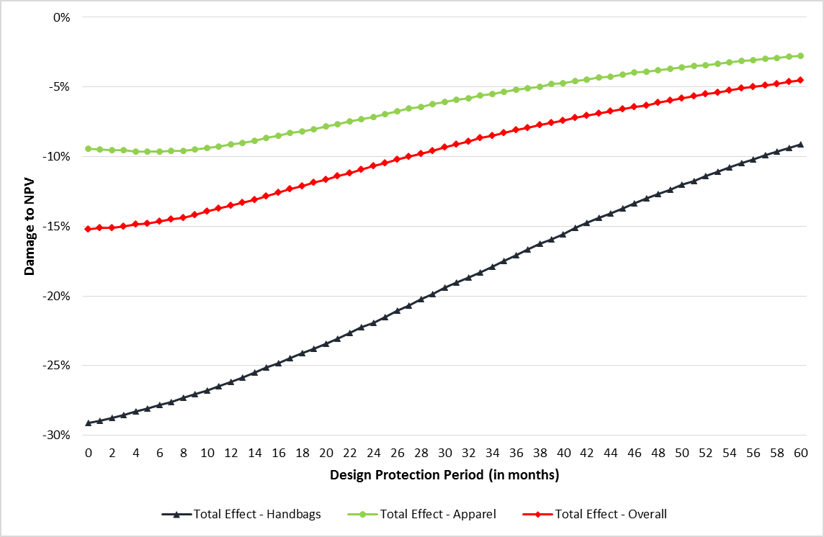
Appendix A: The Ratio Equation and Decomposition of the Total Effect
As explained in the text, the expected ratio of individuals whose uniqueness threshold has been passed is equal in both the adopter population and the available market potential, and thus:
(A1)
Substituting from Equation 3, the number of disadopters in each time period t, is given by:
(A2)
To decompose the various effects, we consider the NPV created in the following scenarios:
- Scenario A. The basic fashion model with no knockoffs. We completely removed knockoffs and their effects by setting α (the share of potential knockoff adopters) to zero.
- Scenario B. Full model: All effects described in Equations 1-4 and A2. The case of a knockoff where acceleration, substitution, and uniqueness occur.
- Scenario C. Uniqueness + Acceleration: In this model, we remove the substitution effect by setting β (the substitution parameter) to zero.
- Scenario D. Acceleration alone: In this scenario, every segment is considering only their segment when disadopting or avoiding the design, while considering both segments when adopting. This way, the only effect one segment has on the other is to accelerate sales.
- Scenario E. Substitution alone: In this scenario, we use Equations 1-4 and A2 with one change: Each segment (original and knockoff adopters) considers only their segment (the level of x_{it}) when considering attrition or adoption. We use this scenario because estimating the substitution effect from Scenario B ignores the interaction between the three effects.
- Acceleration_effect = (Scenario D - Scenario A) / Scenario A
- Uniqueness_effect = (Scenario C - Scenario D) / Scenario A
- Substitution_effect = (Scenario E - Scenario A) / Scenario A
- Total_effect = (Scenario B - Scenario A) / Scenario A
- Interaction = Total_effect - Acceleration _effect - Uniqueness _effect - Substitution _effect
Web Appendices
Web Appendix A: The Process of Selecting the Fashion Items Analyzed
In order to avoid bias originating from our perceptions of fashions, we turned to leading fashion blogs dedicated to matching original designs and their knockoff counterparts. Such blogs were found using Google’s image search function, looking for images that match the search phrases “Cheap vs. Steep”, “Real vs. Steal” and similar phrases. To add an item to our list, we required a photo comparing the two items and their respective prices.
We gathered 300 of these original-knockoff pairs and then searched for the sales data of the original in the retailers’ data. Since we wished to use the sales data gathered for the adoption and use of these fashions, we applied a strict filtering process to ensure that we ended up with the best available data. Thus, a fashion growth pattern was selected if and only if it fulfilled the following criteria:
- We used only monthly-level data, and only data for sales transacted in the US and only to US citizens, in order to minimize geographical and cultural biases.
- We avoided data with strong seasonality effects such as boots, coats, or swimsuits.
- The data needed to have at least 48 continuous data points in addition to sales having already reached a first peak, as estimations before the peak are relatively unstable, and estimations with less than 48 data points resulted in non-significant parameters with large standard deviations in our estimations.
- The sales of the item must be substantial, selling more than 10 items per month on average, and 100 items total.
At the end of this process, we were left with 20 suitable fashions, given in Table 1.
Web Appendix B: The Extended Model Equations
In the extended scenario, we constructed an extended model that takes into account various consumer types. Toward this end, it is convenient to use a typology of consumer types used by Han, Nunes, and Drèze (2010) in the context of brand prominence in the market for luxury goods. One of the advantages of using their terminology is the fact that data are available on the composition of these groups in the market. Patricians are defined as consumers who buy the original items, can differentiate between knockoffs and originals, and are aware of the actual number of originals in the market. Yet they do not care about, and are not affected by, the number of knockoffs in the market, possibly because they mingle only with other patricians (who only buy the originals). Parvenus, on the other hand, buy the original but do care about the number of pirated designs in the market, for many possible reasons such as not being able to differentiate originals from knockoffs. Poseurs are the consumers that for a number of reason, mostly economic oriented, buy the knockoff and not the original. Parvenus and Poseurs do not differentiate between knockoffs and originals, treating them as one. Patricians are immune to the substitution effect, as they consider only the original as worth buying and will not consider the pirated design as an alternative, thus the share of the market lost to substitution is removed only from the Parvenus.
Note that β and α remain the same per class. We add a new parameter, γ, for the level of piracy recognition, or the share of original buyers that differentiates between original and pirated designs. We now modify the equations presented in the paper to accommodate for these three segments. The indices are as follows: i is for original/knockoffs – i = 1: original, i = 2: knockoff, j is for knockoff recognition – j = 1 for knockoff indifferent; j = 2: knockoff cognizant. In x_{ijt} for example: x_{11t} is the Parvenus, x_{12t} is the Patricians, and x_{21t} is the Poseurs.
(WB1)
(WB2)
(WB3)
(WB4)
(WB5)
(WB6)

To decompose the various effects, we follow the same scenarios proposed in Appendix A.
To estimate the proportion of knockoff indifferent (γ), we need to estimate the share of Patricians and Parvenus in the US market. Han, Nunes, and Drèze (2010) used Nielsen’s Claritas tool to identify Patricians. Using their definition of Patricians as “Upper Crusts, Blue Bloods, and Movers & Shakers” segments, we came up with 3.92% for the share of Patricians in 2012, slightly lower than their estimate in 2007. To calculate the share of Parvenus, we added all the other segments belonging to Upscale or Wealthy Income segments, except for three segments that in our opinion and from Nielsen’s description did not belong to the Parvenus: Upward Bound; Fast-Track Families, and Country Casuals, adding up to 16.09%.
We then set γ = .0392/(.0392 + .1609) = .196 - the share of Patricians from the original buyers (if we add the three segments above, γ drops to .179, which is covered in our sensitivity analysis below). Using the same methods, mutatis mutandis, we estimated the parameter range with the new model and ran the simulations with this new parameter.
We find that the damages were indeed lower as expected. However, even with a considerable portion of the consumers can differentiate between original and knockoff, the uniqueness effect is still substantial for both types of products and result 1a still holds: The total negative effect on handbags decreased from -29.1% in the original model to -24.8%; and in the case of apparel from -9.4% in the original model to -4.1%. The median effect across groups decreased from -15.2% to -8.9%. Result 1b also holds, as the acceleration effect is still larger than the substitution effect (with median effect across groups of 15.8% and -0.8% respectively), while the uniqueness effect is larger than the other two (at -25.8%).
Since the percentage of those who can differentiate between the original and knockoffs might vary across product categories, one might wonder if knockoffs’ negative effect will disappear once the share of these discerning consumers (γ) further grows. We examined this question by simulating the model under differing levels of γ . We see that even when γ reaches 40% of the original’s customers, the knockoff effect is still negative, with a total effect (across the two groups) of about -5%. The results are given in Figure WB1.

Figure WB1: Damage of piracy when some buyers differentiate between original and pirated design
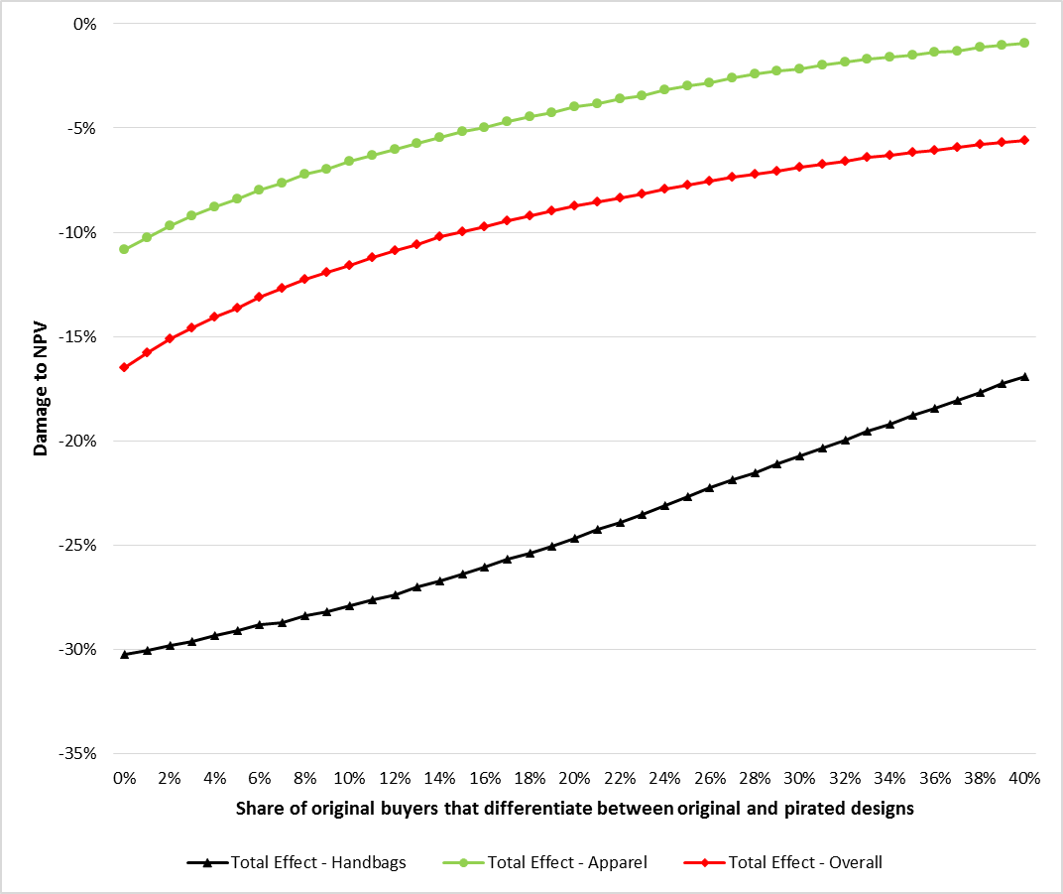

One should note the distinction, which we follow here, between counterfeits, which impersonate a brand including the brand’s logo, and knockoffs, which merely copy its design and appearance.
Note that we use the term “uniqueness” to describe both the need of the consumer as well as the monetary effect stemming from this need. We use the adjectives “need” and “effect” except where the distinction is obvious from the context.
For robustness purposes, we also considered a Uniform distribution and found that it does not change the substantive results presented in what follows.
http://www.claritas.com/MyBestSegments/Default.jsp

